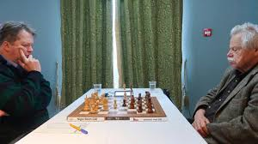
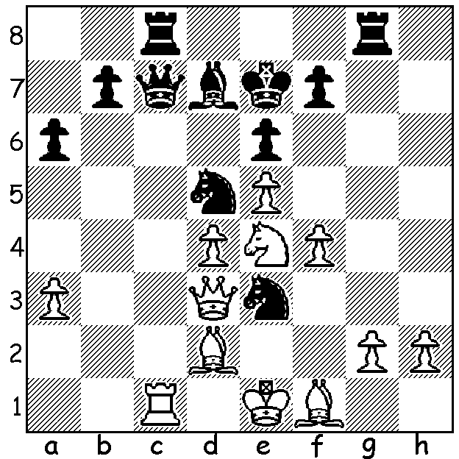
J S Hooker vs Nigel Short 1975: Short vs Hort, Bunratty 2020
(a win by Short aged ten)
Black uses every piece to mate in 6
(unless White surrenders his queen):

RIDDLE: which top ten player is called 'The Artist'?

NIGEL MAKES SHORT SHRIFT OF OPPONENTS
It is pleasing to hear news of Nigel Short, who made such a favourable impression at his 35 board Simul here four years ago. His latest success was in Bunratty, Ireland, one of the best weekenders in Europe, where he scored an unbeaten 5/6, his third win after victories in 2016 & 2017. One of his victims was the legendary Czech GM Vlastimil Hort, now 76. Short, himself 54, called the win in a mere 20 moves 'a triumph of youth'. A former challenger to Garry Kasparov for the world title, Short is now a vice-president of FIDE and was FIDE's supervisor at the last Womens World Championship.

CANDIDATES GOES AHEAD IN RUSSIA
At time of writing the Candidates is about to start in Yekaterinburg, the fourth largest city in Russia, close to the Kazakstan border. Eight of the world's best players compete in a 14 round tournament to find a challenger to world champion Magnus Carlsen with favourites being Fabiano Caruana and Ding Liren. Ding and fellow Chinese qualifier Wang Hao had to go into 14 days isolation within Russia because of the corona virus. It was decided about ten days ago that spectators would not be allowed at the event. Players will be subject to health checks, a nurse will be on hand, hand shakes will be optional and face masks will be available.

SOLUTION: 1...Qxc1+!! 2.Bxc1 Rxc1+ 3.Kf2 (3.Kd2 Rd1+) 3...Bb5 4.Qb3 (4.Qxb5) 4...Rxf1+! 5.Rxf1 Rxg2+ White resigns (6.Kf3 Be2# or 6.Ke1 Re2#).
RIDDLE: Anish Giri because he is always drawing.

