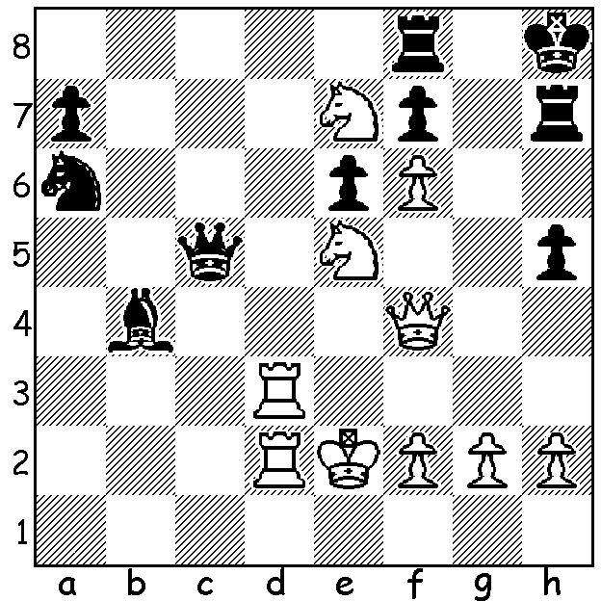

Daniil Dubov vs Anish Giri
(FIDE GP Moscow 2019)
Black has just played 1...Kh8
but resigns before White's next move.
Can you see why?

THE SHOW MUST GO ON
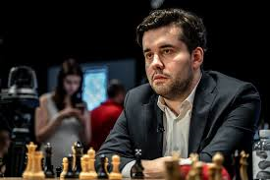
One of the few sporting events to be played at present is the Candidates in Yekaterinburg, Russia, with eight of the world's best competing in a 14 round round robin to find a challenger to world champion Magnus Carlsen in a match
scheduled for later this year. Safety
measures include twice daily medical
checks for everyone involved (temperature,
lung function and throat), optional hand
shakes and face masks being available.
With the tournament close to the half way
stage Russian Ian Nepomniachtchi (4.5/6)
is now favourite after establishing a one
point lead. His third win was gained at the
expense of Ding Liren who suffered his
third loss to be equal last with 2/6. Second Ian Nepomniachchti
at present is Maxime Vachier-Lagrave with 3.5/6 followed by a group of players on 3 including the top rated Fabiano Caruana who lost in Rd 3 to Ding. A scare went up in the Rd 6 post game interview with Nepo coughing frequently. However immediate tests showed he wasn't infected with the coronavirus.

SOUTHERN SUBURBS OPEN
There was just time to complete the Southern Suburbs Open before the closing of the club. Winner was Ihsan Ferozkohi (7/7) followed by Dominador Andador (5.5) and Kathryn and Andrew Hardegen (5). Rating Winners: Under 1800 Brent Geronimo (4.5), Under 1650 Wallace Sheridan and Dylan Gough (4), Under 1500 Harry Geronimo (4).

SOLUTION: White's winning move is 2.Nxf7+! as both White rooks are overworked. If 2.Rfxf7 Rd8+ 3.Rf8 Rxf8# or 2.Rhxf7 Qh6+ 3.Rh7 Qxf8#.

