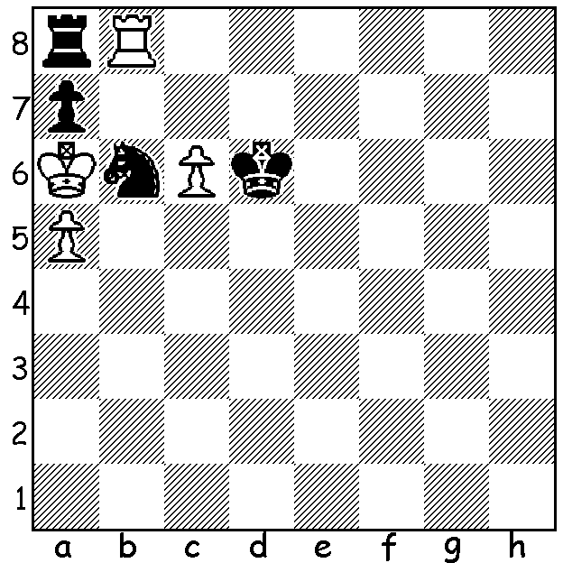

Mikhail Kliatzkin 1924:
White to play and win
(4 moves)

THE SHOW MUST STOP
One of the few sporting events being played after an almost universal sport shutdown was the Candidates in Yekaterinburg, Russia, with eight of the world's best competing in a 14 round double round robin to find a challenger to world champion Magnus Carlsen in a match scheduled for later this year. Health safety measures were meant to ensure that the tournament could be completed but outside events would cause play to be abandoned a few hours before Rd 8, the beginning of the second half when players would play their seven opponents again but with opposite colours to the first half. Rd 7 had seen Maxime Vachier-Lagrave, with a win against leader Ian Nepomniachtchi, draw level with the Russian, thus increasing the chances of the other players. Scores: MVL & Nepomniachchti 4.5/7, Fabiano Caruana, Anish Giri, Wang Hao, Alexander Grischuk 3.5, Ding Liren, Kirill Alekseenko 2.5. What had caused the halt to play was the announcement that Russia was soon to be stopping all international flights, leaving the likelihood of the five non-Russians being stranded. This resulted in a rush for these players to take flights home before the ban was put into effect. It seems probable that the tournament will restart with Rd 8 once the virus danger has passed.
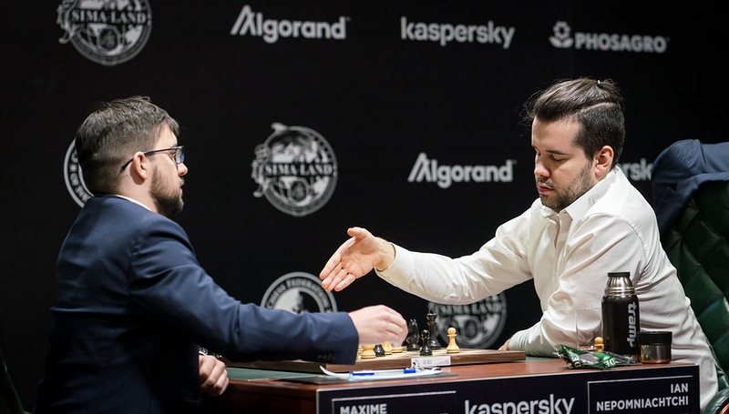

Nepo
resigning
against
MVL

CHESS DURING ISOLATION
If you play Chess you are a fortunate person during the present crisis as there is so much you can do; study openings (perhaps learning some new ones), read chess biographies with annotated games (I plan to complete the five volumes of Kasparov's 'My Great Predecessors'), peruse the many chess web sites, play internet chess (the Metro Club has been organising an online tournament among its players), or solve chess puzzles. The puzzle today is taken from a series of endgame problems I see daily on Facebook thanks to Andrew Hardegen.

SOLUTION: 1.c7! (a deflection enabling the next move to be a check) 1...Kxc7 2.axb6+! Kxb8 3.b7 (Black is in zugzwang) 3...Kc7 4.bxa8=Q. Isn't this a delightful finish?

