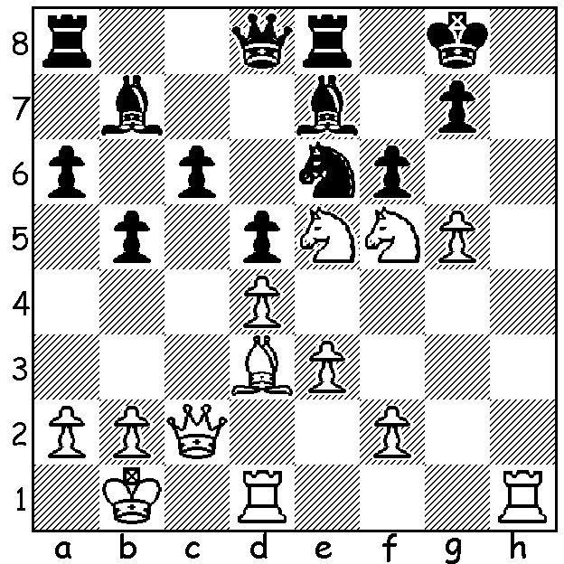

Arianne Caoili vs Betul Cemre Yildiz
White to play and win:

TRAGIC DEATH OF FORMER AUSSIE STAR
On March 15 Arianne Caoili, a former Oceania Womens Chess Champion, died in a hospital in Armenia from injuries after losing control of her car and crashing into a barrier. Arianne was born in the Philippines in 1986 to an Australian mother and Filipino father. The family moved to Australia in 1989. She became Asian Girls Under 16 Champion on her 14th birthday in 2000 and in 2009 she won both the London Chess Classic Womens Invitational tournament and the Oceania Womens Interzonal. She played a draw against Magnus Caelsen in 2001. She played in two Olympiads for the Philippines and in five for Australia. In 2006 her dancing the salsa at a Turin nightclub Olympiad wind-up with the then World No 3 Levon Aronian provoked English GM Danny Gormally, who had previously made friends with her, to attack Aronian before Aronaian's team mates intervened. This incident made front page news throughout the world and was even reported in BoxingScene. She then became known to the wider Australian public in 2006 when she finished second with her partner in Dancing with the Stars. She married Aronian in 2017 after they had become engaged in 2015. Arianne was certainly multi-talented; she was an economist, spoke several languages, she made a 2000km charity bike ride in Armenia, co-founded an Armenian newspaper, owned a jazz club and recorded an EP in Australia.


SOLUTION: 1.Nh6+! gxh6 (1...Kh8 2.Nf7+ or 1...Kf8 2.Ng6#) 2.Bh7+ resigns (2...Kf8 3.Qg6 fxe5 4.Qg8# or 2...Kh8 3.Nf7+ Kg7 4.Qg6+ Kf8 5.Qg8#) - an excellent win against the Turkish women's champion.

