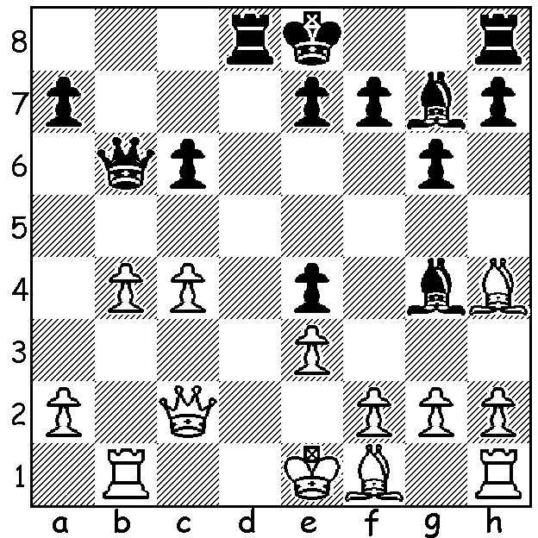
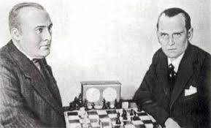
Effim Bogolybov (left) vs Alexander Alekhine
(Blindfold Game 1914) Black has a sensational finish (3 moves):

DEJA VU
Last month the Candidates in Yekaterinburg, Russia, with eight of the world's best competing in a 14 round round robin to find a challenger to world champion Magnus Carlsen, was abruptly halted halfway through as Russia announced plans to stop all international flights, leaving non-Russian players, their teams and the officials rushing to book flights home. A somewhat similar occurrence befell those involved in the Mannheim chess tournaments of 1914 when play ended on August 1 after 11 of the scheduled rounds due to an international crisis, namely the German Declaration of War against Russia. Before the announcement, with the situation deteriorating, the players did not seem particularly concerned with Alekhine saying, "Rumours about political complications did not particularly worry us in Mannheim." Many of the participants in both the Masters and the subsidiary tournaments were taken into custody with a number of them imprisoned for the duration of the war at Triberg. It's said that there was a danger players would be executed as spies with police believing the scoresheets were secret codes. Alekhine who led with 9.5/11 was declared winner, his first major international success, with Milan Vidmar (8.5) second and Rudolf Spielmann (8) third. Prizes were awarded but but not the full amounts with Alekhine receiving 1100 marks which I estimate would be the equivalent to over aus$12000 today.

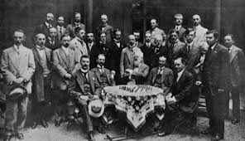

SOLUTION: 1...Qxb4!! 2.Rxb4 Bc3+! 3.Qxc3 Rd1# - two brilliant deflection sacrifices. This game is said to have been played at a German police station where the two players, who had been playing at Mannheim, were waiting to be interrogated.

