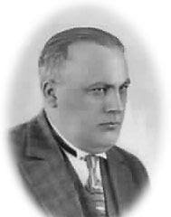
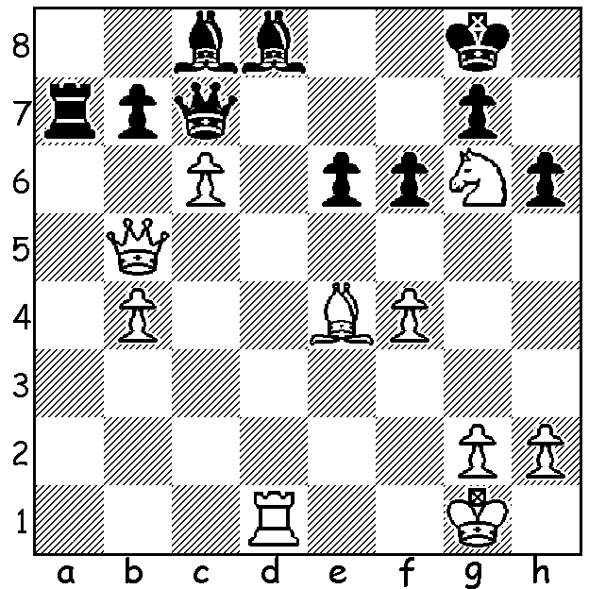

Effim Bogolybov vs Samuil Weinstein
(Triberg 1915):
A brilliant second move wins for White:

CHESS IN CONFINEMENT
Following on from last week with the abandonment of the 1914 Mannheim Chess Congress after Germany's declaration of war against Russia, seven players from the three tournaments (Masters with 18 competitors, Reserves A 17, Reserves B 50) were imprisoned for the duration of the war. During their internment these players organised a series of tournamnets, first at Baden-Baden and then in Triberg. Effim Bogolyubov, who won five of the seven tournaments, remained in Triberg after the war and married a local woman. Alexander Alekhine, the declared winner at Mannheim, was initially taken into custody but was among four participants freed. A doctor certified he was unfit to be drafted into war service although he did join the Russian war effort working for the Red Cross. On his return to Russia he had given simultaneous displays to raise money to help provide aid to those players in imprisonment. Frank Marshall was not interred but spent five days travelling to UK before leaving for New York. His baggage, with belongings and presents received in St Petersburg and elsewhere, was lost only to reach New York five years later. Reminds me of my journey to Perth in August 1972. My trunk containing, among other things, my chess books and opening notes, was lost and only discovered nine months later in Aukland.

SOLUTION: 1.cxb Qb6+ 2.Kh1!! resigns (2...Qxb5 3.Rxd8+ Kh7 4.Rh8# or 3...Kf7 Rf8#: if 2...Bxb7 3.Qe8+ Kh7 4.Qh8#) .

