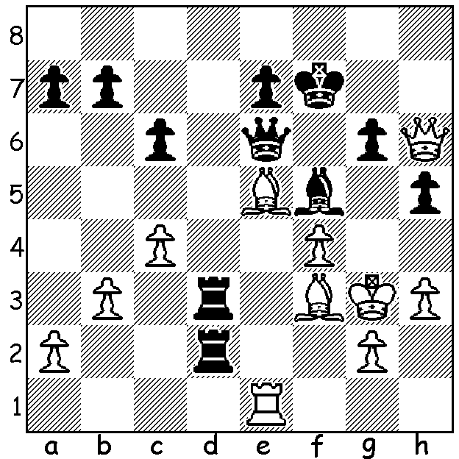

Fabiano Caruana vs Magnus Carlsen Can you name the eight players?
(Carlsen Invitational 2020):
How does Black mate?

TOP PLAYERS ONLINE
With over-the-board chess no longer possible online play is proving something of a substitute both locally and on the international scene. The Metro club has arranged tournaments as have other clubs and enthusiasts are able to watch the Magnus Carlsen Invitational on line tournament in which eight of the world's best players are competing for prize money of $250,000. The field comprises the top five ranked players in the world in classic chess, Carlsen, Fabiano Caruana, Ding Liren, Ian Nepomniatchchi and Maxime Vachier-Lagrave as well as world number one in rapidplay, Hikaru Nakamura, Anish Giri and exciting 16 year old Alireza Firouzja, who recently defeated Magnus Carlsen 103.5 -90.5 in online Bulletchess (1 minute each for the entire game). There are initially seven rounds of four-game rapidplay (15 mins + 10 sec each) mini-matches with the winner of the match scoring three points. If the score is 2-2 an Armegeddon game where White (5 mins) must win while Black (4 mins) can draw to be victor. Points are then 2 for winner and one for loser. The top four players then go forward to semi-finals (if players match scores are level, advance to semis is determined by game scores). The games can be seen on chess24.com (live or recorded) and the tournament goes through to May 3.

SOLUTION: 1...Bxh3 (threat 2.Rxg2+ Kh4 3.Qg4+! Bxg4 4.Rxg4#) 2.gxh3 (2.Rf1 Qg4+) 2...Rxf3+ 3.Kxf3 3...Qxh3+ 4.Ke4 Qd3# (White checks do not alter the outcome).

The eight players are: Firouzja, Carlsen, Caruana, Ding, Nakamura, Giri, MVL, Nepomniatchchi

