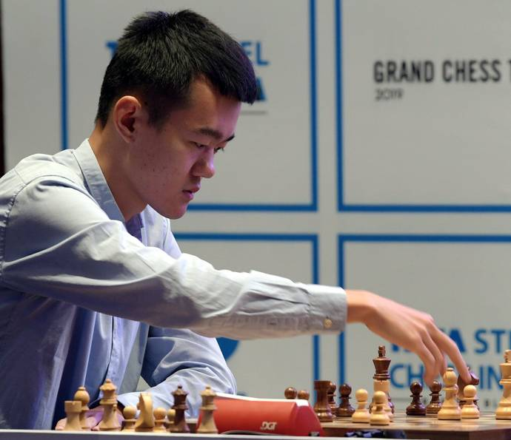
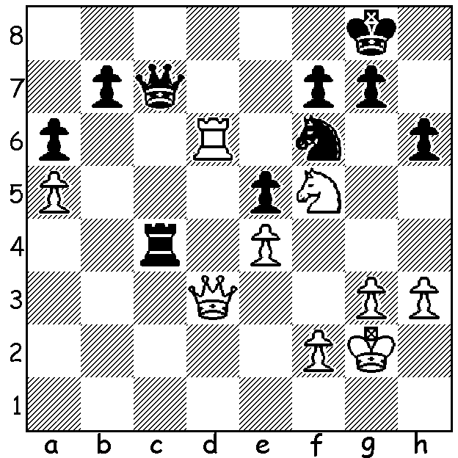
Ding Liren vs Magnus Carlsen Ding Liren
(Carlsen Invitational 2020, Semi-Final, Game 2):
Black plays 1...Kh7? How does this lose?
Suggest better moves foe Black.

FAST and FURIOUS
This is how the UK Guardian Sportsblog described the final games of the Magnus Carlsen Invitational online chess tournament which had been contested by eight of the world's best players. The report continued, 'Carlsen and Nakamura transform Chess into an adrenaline sport '. The preliminaries finished with Hikaru Nakamura and Ding Liren finishing with 15/21, followed by Carlsen (who appeared to take his foot off the pedal once he had qualified for the finals) and Fabiano Caruana (13), Ian Nepomniatchchi (8), teenager Alireza Firouzja and Anish Giri (7), Maxime Vachier-Lagrave (6). Four-game (10min + 10sec) mini-matches were played with an Armegeddon Game (White 5min, Black 4min) to decide in case of a 2-2 draw (Black only needing a draw to take the match). Winners of each match scored 3 points, loser nil, unless an Armegeddon game was needed when winner would get 2 points, loser one point. The semi-finals brought together the two US players with Nakamura defeating Caruana 4-2 after winning the two 5min Blitz games after scores had been locked 2-2. Carlsen, despite having lost to Ding 1-3 in the preliminaries and, after an initial draw, losing the second game of the semi, progressed with a 2.5-1.5 win. In the final Carlsen was facing in Nakamura the best Blitz player in the world but prevailed with two wins to one loss after Nakamura had to concede a draw in their final game. The games were watched by an estimated 10 million who witnessed Carlsen swearing and scowling after blundering against Liren before fist-pumping after winning their next game. For his efforts Carlsen won US$70,000 of the $25,000 prize fund.

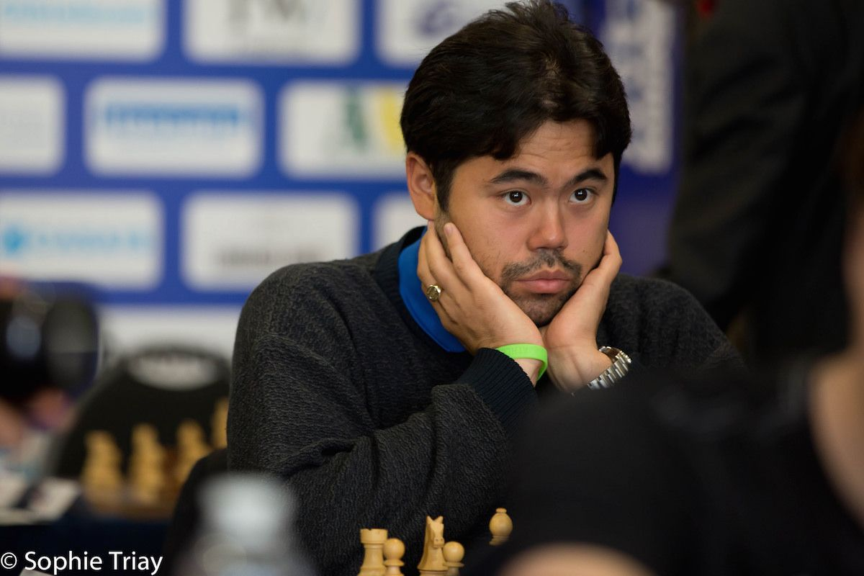

Magnus Carlsen and Hikaru Nakamura

SOLUTION: 2. Rxf6! gxf6 3.Qe3 and mates. This blunder visibly annoyed Carlsen (see above). Probably Black was defending against the threat of 2.Nxh6+ gxh6 3.Rxf6. Better moves were 1...Rc3 (2.Qe2 Ne8) or even 1...Rd4!? but not 1...Rxe4? 2.Rxf6! nor 1...Nxe4? 2.Rd7 Qc5 3.Rd8+ Kh7 4.Ne3 Rb4 5.Qd7 with dangerous penetration.

