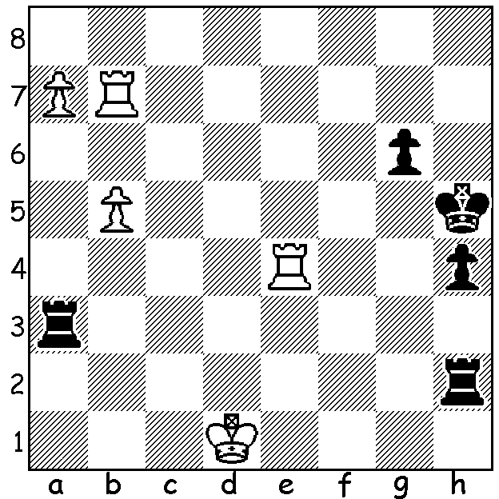


Levon Aronian vs Wei Yi (Nations Cup 2020, Europe vs China):
faced with mate White brings off a surprising draw (4 moves):

CHESS FOR THE WORLD
Following chess24's Magnus Carlsen Invitational, chess.com ran the Nations Cup, an International online team event with six teams, China,USA, Russia, India, Europe, Rest of World, each with three men and one woman. Although Carlsen declined an invitation to represent Europe, the event attracted many of the world's best. Names you will be familiar with - Ding Liren, Hou Yifan (the world's top rated woman), Ju Wenjun (women's world champion), Hikaru Nakamura, Fabiano Caruana, Wesley So, Ian Nepomnaiachtchi, Sergey Karjakin, Vishy Anand, Maxine Vachier-Lagrave, Levon Aronian, Alireza Firouzja. A double round-robin with a time limit of 25min + 10sec played between 3rd and 9th May, the event culminated in a final between the top two teams. Coming into the final day of preliminaries China was well ahead of USA who were a match point (= 1 drawn match) ahead of Europe. On the final day Europe defeated USA 2.5 - 1.5 thanks to a single win by Nana Dzagnideze over Irina Krush and with the easier final match were expected to progress to the final. However USA won their final match against China 2.5 - 1.5 while Europe, thanks mainly to Firouzja's defeat of Aronian, were held to a draw by the Rest of the World. With USA and Europe equal on 13/20 USA went through to the final with points score of 25.5/40 compared to 25, despite having lost their two matches against Europe. Other scores: China 17/20, Russia 8, India 5, Rest of World 4. Final report next week.

SOLUTION: 1.Rxh4+! Rxh4 2.Rh7+ Kg5 3.Rxh4 Rxa7 (not 3...Kxh4 when 4.b6 wins for White) 4.Rg4 Kf6 Draw Agreed.

