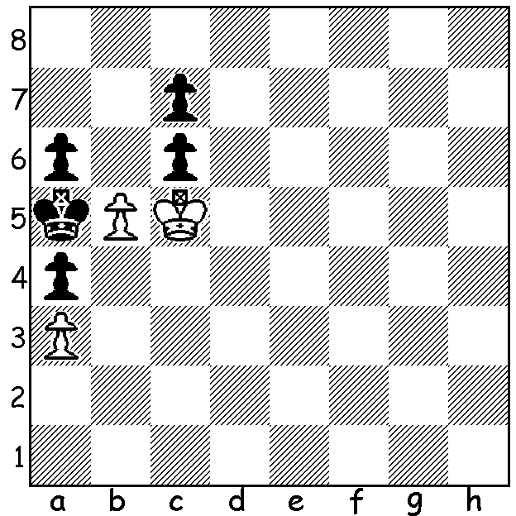

[DIAGRAM HERE]
I've recently been receiving
endgame studies on email.
(Votruba1901) has White
to play and win.

CHINA USA SHOWDOWN

The Nations Cup, an International online team event (25min + 10sec) with six teams, China,USA, Russia, India, Europe, Rest of World, each with three men and one woman, concluded with with a final between China and USA. China had convincingly won the qualifying tournament with 17/20 match points while USA had pipped Europe by the slimmest of margins to reach the final; with the teams finishing level on 13/20 match points, USA had
scored 25.5 game points to Europe's 25. Having lost to
China in their first encounter, the Americans had stormed
back to win the return encounter in the final qualifying
match. The final, as expected, was closely fought with a
final 2-2 draw leaving China deserved winners. Scores:
Ding Liren - Hikaru Nakamura =, Wei Yi - Fabiano
Caruana 0-1, Yu Yangyi - Wesley So 1-0, Hou Yifan -
Irina Krush =. China's winner in the final, Yi Yangyi,
finished with 7.5/10, losing only to So in the final
qualifying match. The best overall result was gained
by Fabiano Caruana (USA) with 7.5/9 which included
three wins against China. Yu Yangyi (preferred to
Wang Hao in Final)

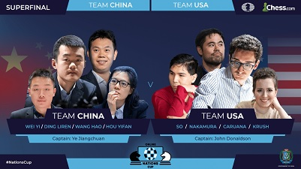

ONLINE CHESS: it has been estimated that 16 million games are being played online every day.

RESUMPTION OF PLAY IN WA:following the latest easing of restrictions, the Kingsley Junior Club will resume playing on Tuesday 26 May. It is expected that the senior clubs will soon be re-opening as well. Players should check cawa.org.au for latest information.

SOLUTION: 1.b6! cxb+ 2.Kxc6 b5 3.Kc5 b4 4.axb#.

