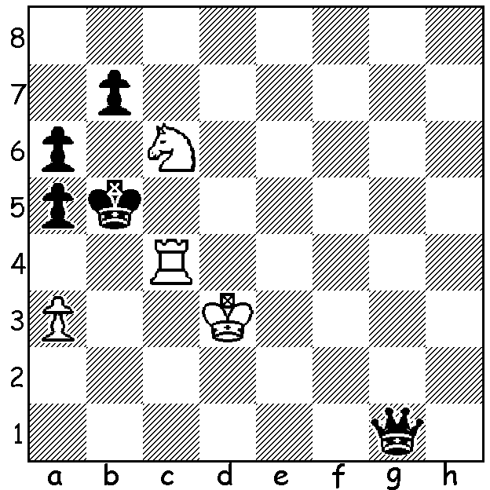

Another endgame study
(Dimitri Petrov 1975):
despite a very negative
imbalance in material
White can win
(3 moves 2 variations):

MORE ELITE ONLINE RAPIDPLAY
The Lindores Abbey Rapid Challenge (15min + 10sec) has 12 leadings GMs playing for a combined prize fund of US$150,000. The contestants have firstly played each other in a Round Robin with the best eight going into a knockout quarter-final. Top place was gained by Hikaru Nakamura with 7.5/11. He was followed by Sergey Karjakin 7, Yu Yangyi, Wesley So, world champion Magnus Carlsen, Ding Liren all 6, Danil Dubov, Levon Aronian, Alexander Grischuk all 5.5, Alirreza Firouzja 4.5, Jan-Krzysztof Duda 4, Wei Yi 2.5. Grischuk, a three-times world blitz champion, was the unlucky one of the three players on 5.5 to be eliminated on tie-break.

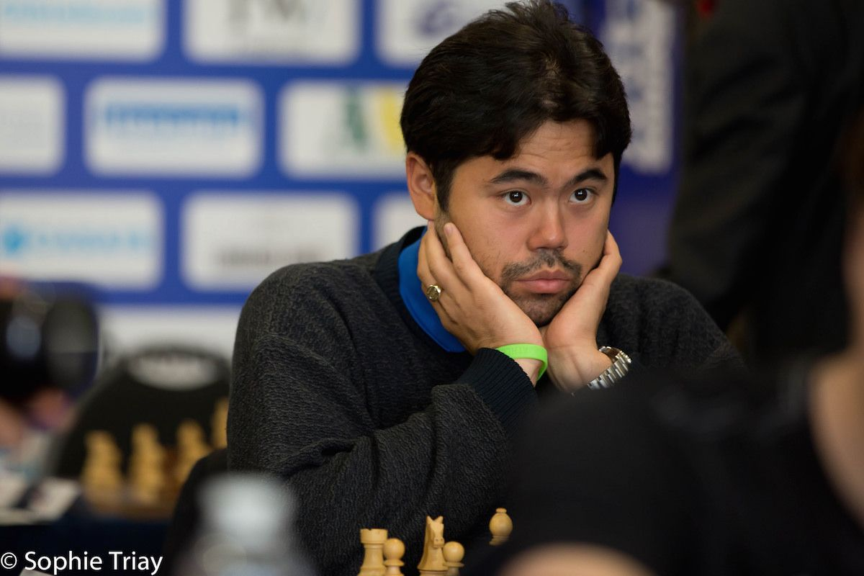
SOME CHESS QUOTES: 'Play the opening
like a book, the middle game like a magician and
the endgame like a machine' (Rudolph Spielmann).
'An intriguing phenomenom which links Mathematics,
Music and Chess is the fact that child prodigies have
been known in only these fields' (Edward Lasker).

SOLUTION: 1.Na7+!! Qxa7 2.a4+ Kb6 3.Rc8 and
Black is in zugzwang, forced to lose his queen: if he
declines the knight sacrifice with 1... Kb6 he loses to
2.Nc8+ Kb5 3.a4#. Hikaru Nakamura

