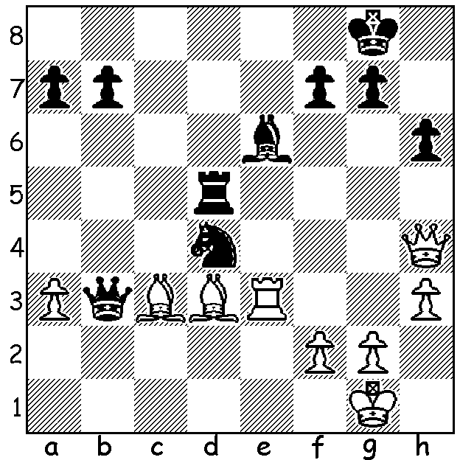

[DIAGRAM HERE]
Yu Yangyi vs Ding Liren
(Lindores Abbey ¼ finals):
Should Black play 1...Qxc3?

LINDORES ABBEY CHALLENGE Part 2

The quarter finals of the Lindores Abbey Rapid Online Challenge (15min + 10sec) were best of three mini-matches of four games with an Armegeddon game to be played if any of matches finished 2-2. Scores: Hikaru Nakamura def Levon Aronian 2-0; Magnus Carlsen def Wesley So 2-0; Daniil Dubov def Sergey Karjakin 2-1; Ding Liren def Yu Yangyi 2-1. In the first match against compatriot Yu Yangyi, Ding Liren, despite being a piece up in the ending, lost an Armegeddon game on time (no increments, White 5min, Black 4min, with White having to win). He then won the second match 2.5-1.5 before progressing to the semi-final by drawing with Black in another Armegeddon.

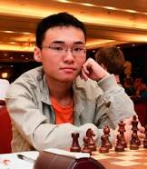
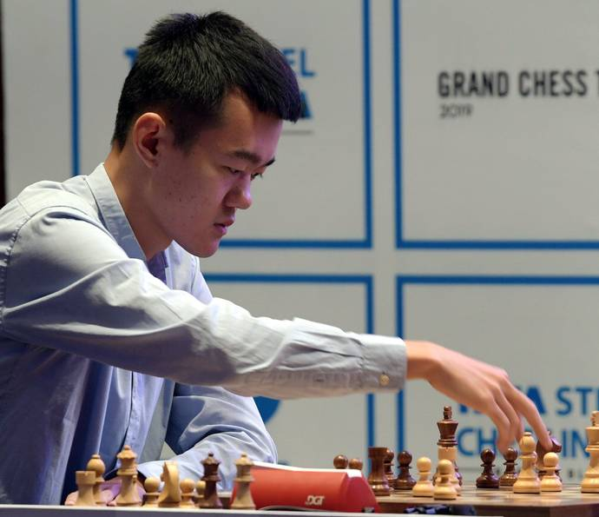
Ding Liren Yu Yangyi

In the semi-finals Nakamura, the best blitz player in the world, was beaten 0-3 in the first match against world champion Carlsen but won the second 2-5-1.5 and then, in the third match, won the Armegeddon with the Black pieces. He was joined in the final by young Russian Daniil Dubov who defeated Ding 2.5-1.5 and 2.5-0.5.

ARTIST/CARTOONIST, possibly tertiary student, sought as illustrator for a forthcoming publication of humerous verse (some with a chess theme). Contact me on ellisd19@bigpond.com or 0439798607.

SOLUTION: 1...Qxc3 loses the queen to 2.Bh7+. However after 2...Kxh7 3.Rxc3 Black has the fork 3...Ne2+ 4.Kh2 Nxc3 and the three pieces were to prove too strong for the White queen with Black building up a mating attack.

