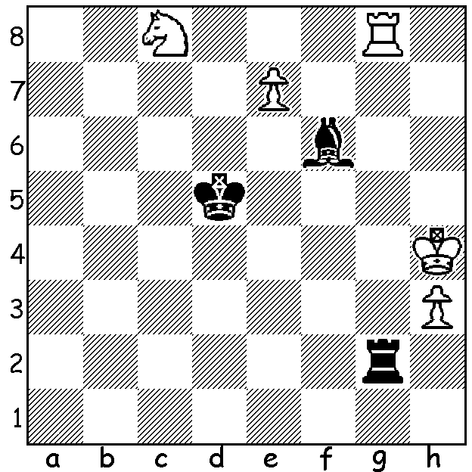

Can you state 4 ways a
player can force a draw
(exclude agreement)?
Now work out how
White can draw (4 moves)
(Nikolai Kralin 1977)

LINDORES ABBEY CHALLENGE FINAL
After topping the preliminary section and defeating world champion Magnus Carlsen in the semi-final, Hikaru Nakamura, the best Blitz player in the world, was favoutite to defeat 24 year old Russian Daniil Dubov in the final of the Lindores Abbey Rapid Online Challenge (15min + 10sec). Nakamura got off to a good start, winning the first two games. Dubov won the third but could only draw the fourth to lose the first mini-match 1.5-2.5. He won the first game of the second match and played out three draws to win the second 2.5-1.5, taking the final into a concluding match. After a draw, Dubov took the lead but this was nullified by Nakamura in the next game. A fourth game draw meant the final would be decided by an Armegeddon game (no increments, White 5min, Black 4min, with White having to win). Nakamura, as usual, chose Black but after missing a simple zwischenzug on move 12 was soon in a losing position and resigned after 45 moves. For his victory Dubov received US$45,000 with Nakamura earning $25,000 as runner-up.

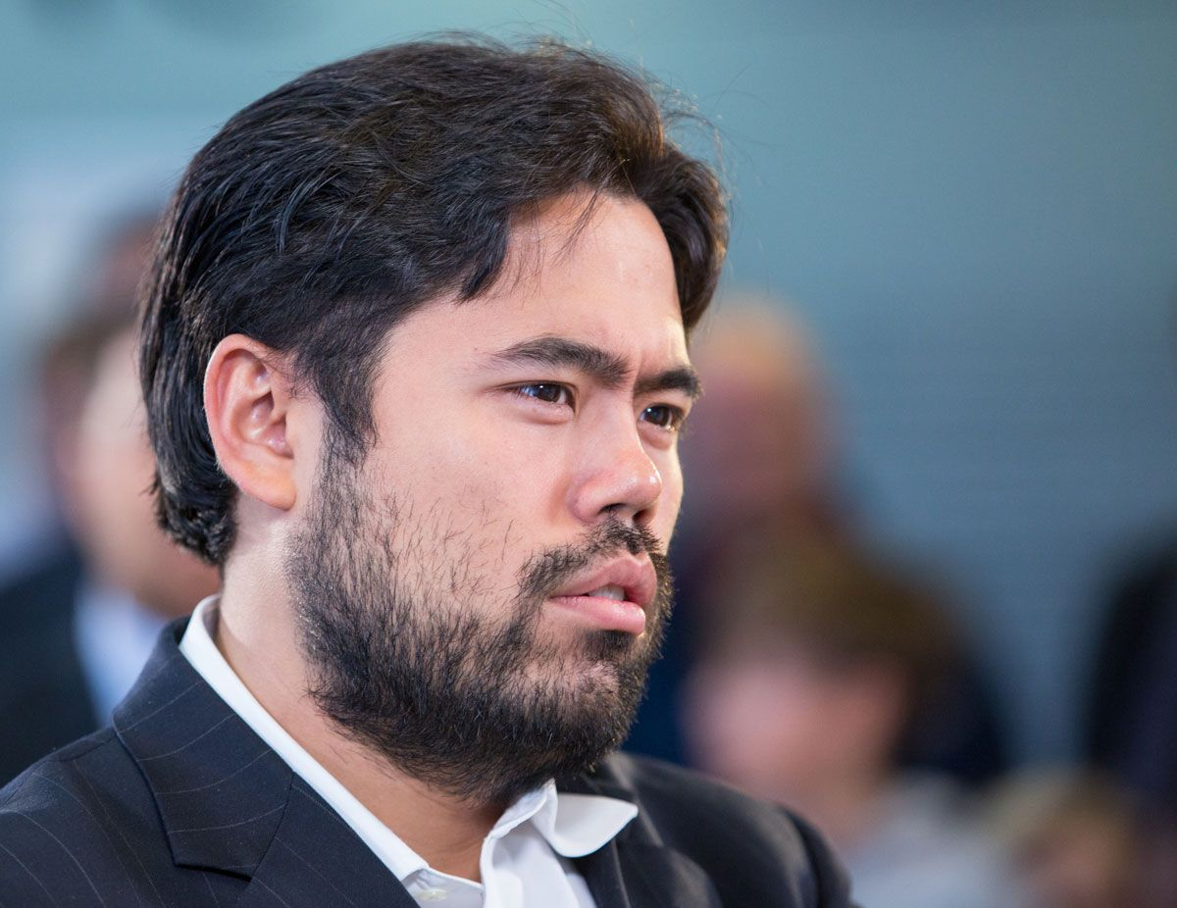


Dubov (above) and Nakamura

CLUBS REOPENING: Metro will resume club championship Thursday 18 June.
Southern Suburbs: David Ellis Cup - 6 rounds commencing 11 August.
Perth Club reopened this week, Wed 10 June.

SOLUTION: Four ways to draw:
1. Triple repetition of position with same person to move each time;
2. Opponent does not have sufficient material to mate;
3. Stalemate.
4. Play 50 moves without a piece being taken or a pawn moved.
Problem: 1 Rg5+! Rxg5 (1...Bxg5+ Kh5=) 2.e8=N! Bd8 3.Ne7+! Bxe7 4.Nf6+! Bxf6 Stalemate.

