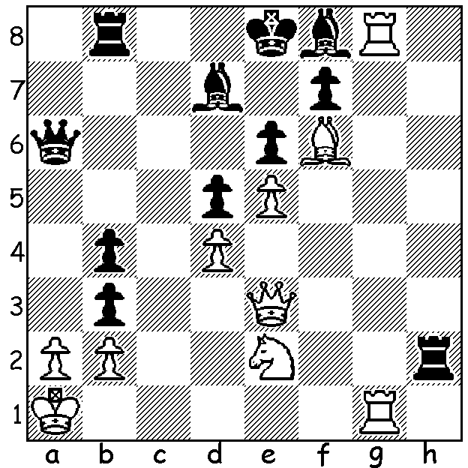


Daniil Dubov, White vs Yangurazov 2006: can you find a win?

WHO IS DANIIL DUBOV?
Last week I reported on Daniil Dubov defeating Hikaru Nakamura in the final of the Lindores Abbey Rapid Online Challenge. Many readers may not have heard much about Dubov who is is a Russian, aged 24. He became a Grandmaster just short of his fifteenth birthday and in 2018 won the World Rapid Chess Championship. He served as one of Magnus Carlsen's seconds in the 2018 World Championship against Fabiano Caruana. His highest rating of 2709 was achieved in September 2018 and he is currently rated 38th in the world.

JUNIOR ONLINE CHESS: it is still possible for juniors to join this tournament which already has 44 entrants. There is no entry fee and the time limit is 30min + 20sec. Enter on chesswa.club which is a secure site.

WINTER ALLEGRO: venue N Woodvale Primary: date Sunday 28 June, 10.15 - 5.00: time limit 15min + 2sec: see cawa.org.au for full details and entry.

SOLUTION: 1.Rxf8+! Kxf8 2. Rg8+! Kxg8 3.Qg3/5+ Kf8 4.Qg7+ Ke8 5.Qg8#.

