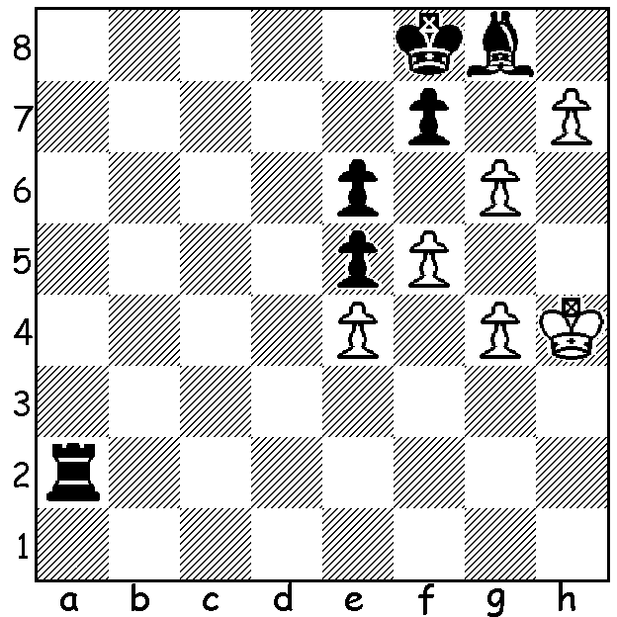

Problem: Bagdasarian 1937:
White to play, two variations
leading to opposite results
but both drawn:

Three weeks ago I reported on the quarter finals of the Lindores Abbey Rapid (won by Daniil Dubov), including the Ding Liren - Yu Yangi matches. Ding had lost the first match but was ahead 2-1 in the second. Playing Black in the 4th game, a loss would see an Armegeddon game and possible elimination while a draw would ensure a third mini match,.We might have expected him to play safe but instead he chose a gambit line, sacrificing a pawn and then the exchange:

Yu Yangi - Ding Liren (Two Knights Defence, Fried Liver Attack)
1.e4 e5 2.Nf3 Nc6 3.Bc4 Nf6
4.Ng5 d5 5.exd Na5 6.Bb5+ c6
7.dxc bxc 8.Qf3 cxb5 9.Qxa8 Be7
10.0-0 h6 11.Ne4 Qd7 12.Nxf6 gxf6!
13.Qe4 Rg8 14.f3 Bc5+ 15.d4 Bxd4+
16.Be3 Qh3 17.Rf2 Bb7! 18.Qh7 Rxg2+!
19.Rxg2 Bxe3+ 20.Kh1 Qxf3 21.Qg8+ Ke7
22.Nc3 Bg4 23.Rg1 Qf2 (although in a winning position
Ding secures the draw) 24.Qb8 Bxg2+ 25.Rxg2 Qf1+
26.Rg1 Qf3+ taking a draw by perpetual. Ding then went on to win the third match.

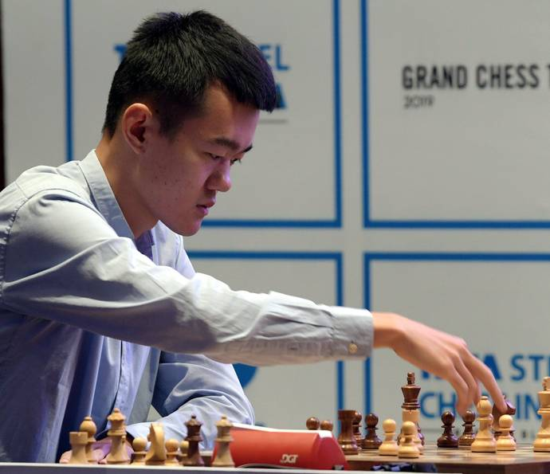
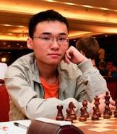
Ding Liren Yu Yangyi

WINTER ALLEGRO (15min + 2sec), tomorrow at N. Woodvale Primary, 10.15 start. Please arrive no later than 10.00. Contact Allan 0439 912 234.

SOLUTION: 1.h8=Q Rh2+ 2.Kg5 Rxh8 3.g7+ Kxg7 4.f6+ Kh7 (4...Kf8 & White is stalemated) 5.Kh5 now Black is stalemated!

