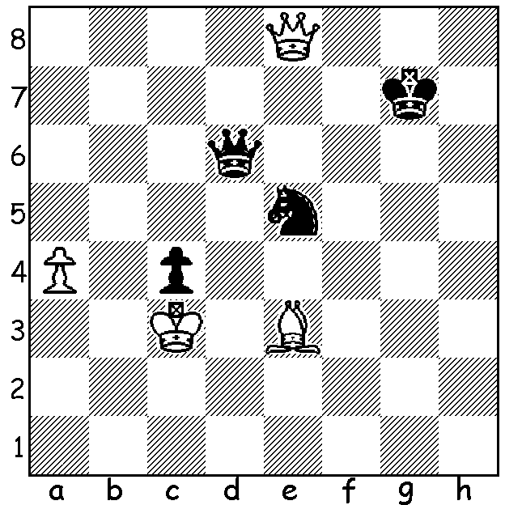

Problem: Robert Korpalski:
White to play and win:
this is not as easy as it looks
as Black has a clever resource
which almost draws (7 moves):

I've seen three references on Facebook in the past week about Chess being racist in pitting White against Black and always giving White the first move. I'd like to refer readers to one of my columns over nine years ago: 'The Swiss Parliament will debate a motion next week for a ban on the teaching of Chess in all the country's schools. Supporters of the motion maintain that Chess, with its warlike associations, is not in keeping with the nation's peace-loving image, that Chess may cause some youngsters to have an unhealthy fixation on the game to the detriment of their studies, that playing Chess encourages unhealthy rivalries, causes psychological harm to the regular losers and damages racial harmony by pitting White against Black.'
Perhaps the motion should also have accused Chess of being sexist as the King is considered the most important of the pieces, needing constant coddling, while the Queen is left to do much of the hard work on the board.

WA BLITZ CHAMPIONSHIP: tomorrow at Leeming Primary, 1.00 - 4.00pm (do get there by 12.45): time limit 3min + 2sec: contact andrewhardegen@iinet.net.au or 0407421084.

SOLUTION: 1.Qxe5+ Qxe5+ 2.Bd4 Kf6 3.a5! (zwischenzug) 3...Ke6 4.Bxe5 Kd7! (did you realise it was the wrong rook's pawn?) 5.a6 Kc6 6.Bd4 Kc7 7.Ba7! (keeping the Black king from reaching a8 and drawing; now the White king can capture the pawn and reach b7 and then the pawn can promote). NOTE: the reference column was for April 1 of 2011!

