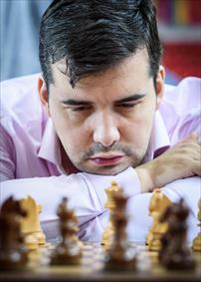
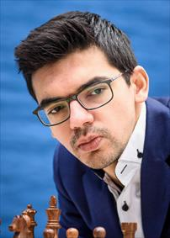
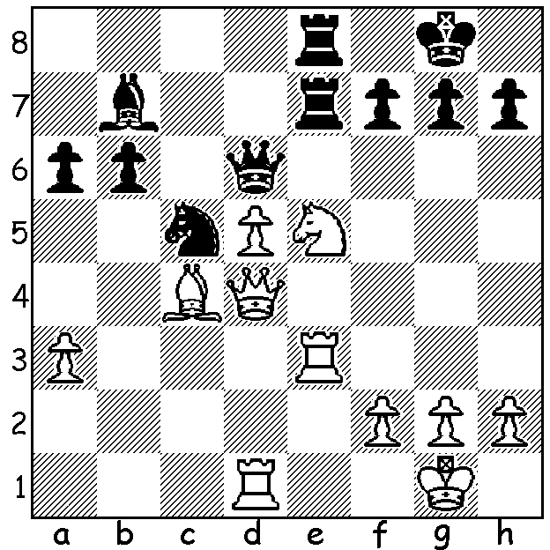

Anish Giri v Ian Nepomniachtchi: White to play and win:
a sacrifice and a further offer enables White to decisively
activate two of his units:

CARLSEN VICTORIOUS AGAIN

Twelve of the world's top GMs competed in the third event in the Magnus Carlsen Grand Tour on line the Chessables Masters with a time control of 15min + 10sec. Two groups of six played two games against each opponent with the top four in each group
progressing to the knockout phase where players competed
in best of three mini matches. Carlsen defeated dangerous
rivals Fabiano Caruana and Ding Liren in successive rounds
and faced Anish Giri in the final. Their first mini match went
to blitz chess after finishing 2-2 in the Rapidplay with Carlsen
winning the second blitz game despite losing two of his five
minutes through a disconnection. In the second match Carlsen
won game 1 and drew the other three to gain yet another tournament victoty. The win was gained despite getting inferior positions in some games with his superior ability to calculate when short of time being the decisive factor.

THE WA BLITZ CHAMPIONSHIP was won by Patrick Gong. Report next week.

SOLUTION: 1.Nxf7!! Kxf7 (declining is no good, eg 1...Qd7 2.Nh6+! gxh6 3.Rxe7 Rxe7 4.d6+ Re6 5.Qxc5! bxc5 6.Bxe6+ Qxe6 7.d7) 2.Re6! Qd8 (the queen is lost after 2...Rxe6 3.dxe6+ Rxe6 4.Qxd6) 3.Qf4+ Kg8 4.Rxe7 Rxe7 5.d6+ Re6 6.d7. A great finish in a limited time game as White brilliantly activates his Bishop and passed pawn.

