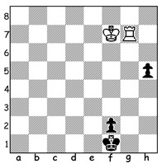

Problem: Chekhover 1948:
Black is intent on queening
a pawn but White, to play,
can draw:

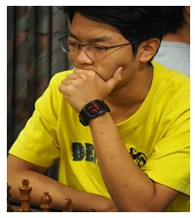
WA BLITZ CHAMPIONSHIP:
Last week I reported that Patrick Gong had won
the WA Blitz Championship (27 players) with the
fine score of 10/11 (losing only to Bozidar Mandic
who finished equal third). Tim Hare, second overall
with 8.5, was the top Senior; Yihe Rebo Fu (7.5) was
equal third and top Junior; Kathryn Hardegen (6.5)
was Womens Champion; First Under1800 Bekzod
Rasulov & Kundan Dharmapuri with 6;

Patrick Gong

BEST WEST AUSTRALIANS IN AUSTRALIAN JUNE RATINGS:
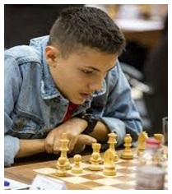
Temur Kuybokarov 2649, 2nd highest in Australia,
(31 pts behind Anton Smirnov - these two are also the
top Under 20 Juniors), 14th Patrick Gong 2399,
16th Tristan Boyd 2393, 21st Ihsan Ferozkohi 2370:
Women - 5th Kathryn Hardegen 2121:
Rebo Fu 1896 - Under 20 20th, Under 18 14th,
Under 16 8th, Under 14 4th:
Under 16 - 13th Jamie Laubbacher 1809,
15th Benjamin Hurst 1801:
Oscar Gao 1361, Under 14 7th, Under 12 2nd:
Seniors (over 65) - 5th David Ellis 2035.

Temur Kuybakarov

SOLUTION: 1.Kg7! (it is vital to free the rook as well as retaining protection of the rook on the f-h files) 1...h4 2.Rh7 h3 3.Rxh3 Kg7 4.Rh7 f8=Q 5.Rg7+ and White either has a perpetual check on the g & h files or wins the queen with Rf7+.

