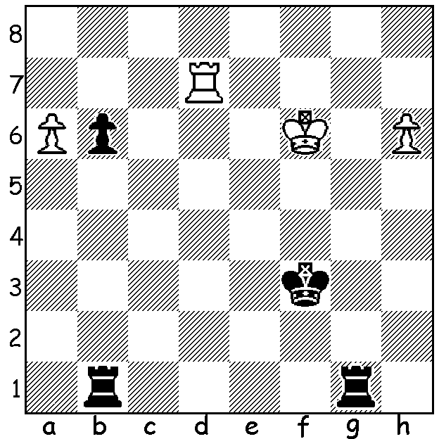

Problem: Rinck 1929:
White can win despite
the rook deficit (3 moves)

WA JUNIOR CHAMPIONSHIPS:
Played during the school holidays, the WA Junior Championships had a total entry of over one hundred. Junior Champion (Under 18) was Yihe (Rebo) Fu (7/7). Other leading scores: Jamie Laubbacher (6), Brent Geronimo, Oscar Gao, Alistair Berry and Kundan Dharmapuri (4). Jamie became Under 16 Champion while Oscar and Kundan shared first spot Under 14. The Under 12 title went to Eu Jin Khaw (7.5/9) with Barath Harirajesh (7) second. Winner of the Under 10 was Anthony Nguyen (9/9) with Yonal De Vas second (7.5). Eric Deng and Angus Chen (8/9) shared top spot in the Under 8. Rebo also won the WA Junior Blitz with 10.5/11 followed by Oscar, Jamie and Brent (8). Under 18 Girls - 1st= Celine Ong & Emily Zhang; Under 12 Girls - 1st Anoushka Gupta, 2nd Paula Gruber; Under 10 Girls - 1st Kobe Wu, 2nd Nithuli Liyanage; Under 8 Girls - 1st Senudi De Vas, 2nd Natalie Levy.
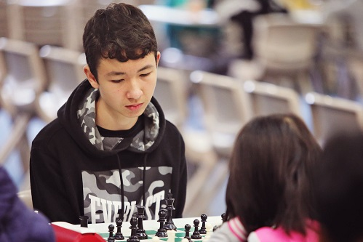
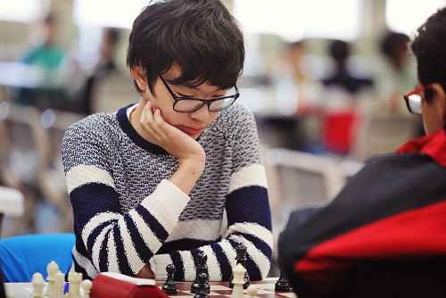
Rebo Jamie

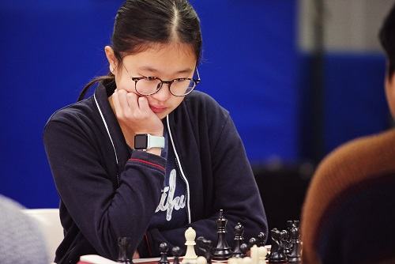
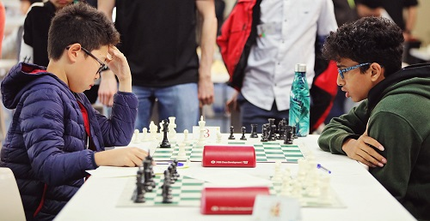

Oscar and Kundan Celine

WORLD NEWS:
Last Monday, 20 July, was International Chess Day, the 96th anniversary of the founding of FIDE (International Chess Federation) in Paris in 1924.
International over-the-board chess has resumed with the annual Biel, Switzerland, GM and other tournaments starting this week. Screens have been placed between players and other precautionary measures put in place to minimise health risks.

SOLUTION: 1.h7 Rh1 2.a7 Ra1 (these moves can be interchanged) 3.Rd1! and White will queen a pawn.

