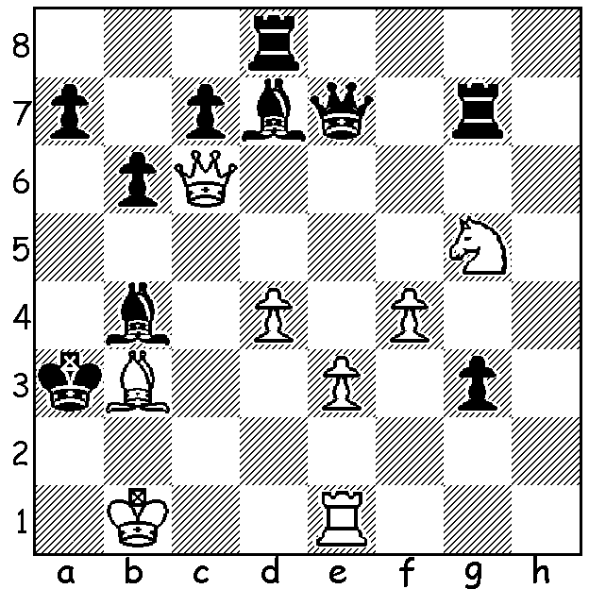

Daniil Dubov v Rasmus Svane 2019:
A rook down and with queen and rook
under attack White mates quickly:

DANIIL DUBOV ON THE GM SCENE
'If ... you ask me how many people in the world
a) work at least 4-6 hours a day long term,
b) take care of their physical fitness,
c) have a strong character, a desire to fight and win,
then I'll surprise you. There are maybe 5-6 people like that in the world who manage to combine it all. And among those he's the best. He is undoubredly number one in the world by a big margin. If someone topples him from the throne, it'll be a shock for the chess world. His strength is that he doesn't particularly have any. And therefore he can play any style.'
No need to ask who he is talking about; clearly Magnus Carlsen.



WORLD NEWS
The FIDE Chess Olympiad started 25 July and concludes 30 August with 163 teams and over 1500 participants. Each team consists of six main players, including at least two women, at least one player who is 20 or younger. Each team may have up to six reserves. Time limit 15 min for each game with 5 sec increments. A mamoth logistical nightmare with different time zones and with the possibility of teams' players scattered, eg Australia's top two players Anton Smirnov in Sydney and Temur Kuybokarov in Perth.

SOLUTION: 1.Qc1+! Kxb3 2.Qc2+ Ka3 3.Qa2#.

