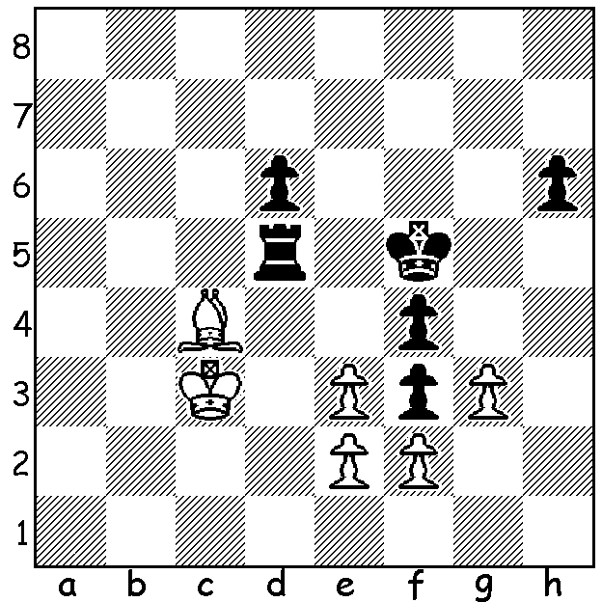

Selesniev 1921:
White to play and win;
White wins the rook but
it takes 7 forcing moves

GM OVER-THE-BOARD CHESS RESUMES
As reported a fortnight ago GM over-the- board chess resumed in Biel, Switzerland. The Chess Festival attracted over 150 participants with the main event between eight Grandmasters locking horns in a 'triathlon', competing in Blitz, Rapidplay and Classic chess. Winner was Radoslaw Wojtaszek (Poland) with 37pts closely followed by Pentala Harikrishna (India) with 36.5 and Michael Adams (UK) 35.5. Scoring: Blitz win 1pt, draw 0.5; Rapidplay win 2pts, draw 1; Classic win 4pts, draw 1.5. Harikrishna (who won the 960 event before the start of the official tournament) topped the Classic but performed badly in the Blitz. while Wojtaszek tied first in Blitz, won the Rapid and was second in Classic. Health safety measures included a plexiglass shield dividing each pair of contestants and no spectators.

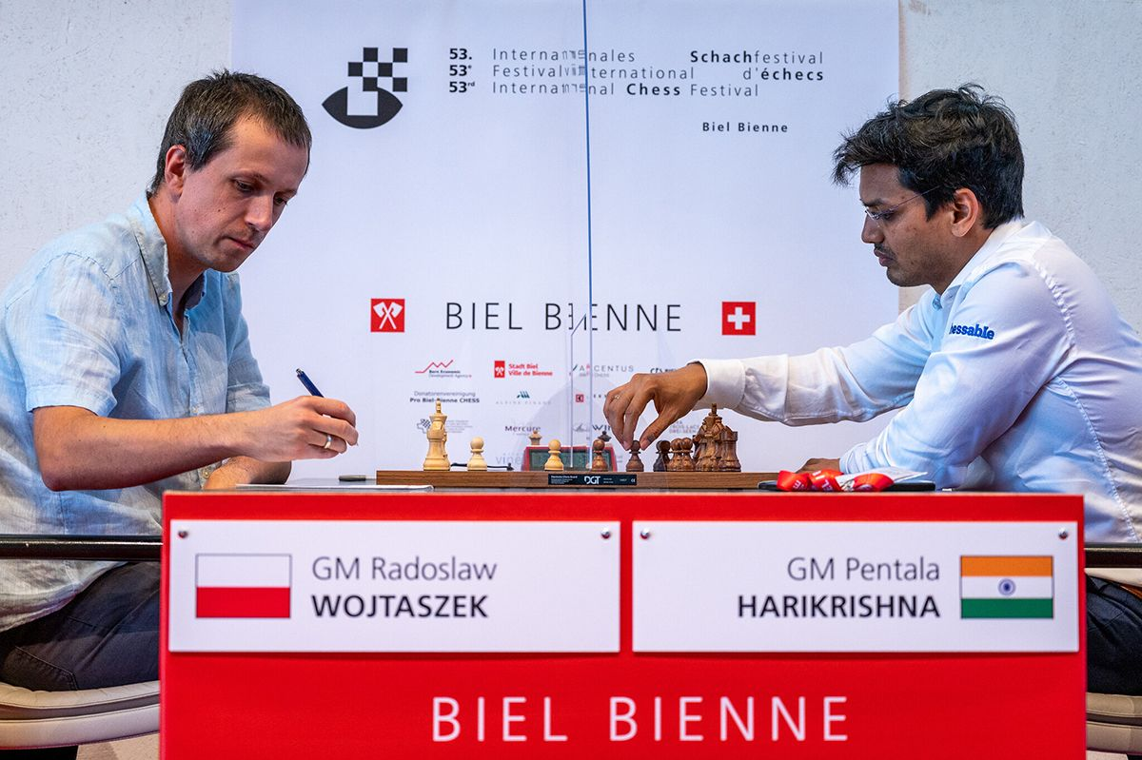

SOUTH OF RIVER CHESS FESTIVAL (ALLEGRO AND BLITZ)
Dates: Allegro Rds 1-4 Thursday 13 August, Rds 5-8 20 August (start 7.15)
Blitz Rds 1-11 Thursday 27 August.
Venue: Cirque Community Space, 63 Kishorn Rd, Mt Pleasant.
Contact: ianmcateer11@gmail.com

SOLUTION: 1.e4+! ( 1.Bxd5 loses to 1...fxg and Black queens) 1...Kxe4 2.exf3+ Ke5 (if 2...Kxf3 Bxd5+ wins) 3.gxf+ Ke6 4.f5+ Ke5 5.f4+ Ke4 6.f3+ Kxf5 7.Bxd5 and White's king has just enough time to catch the h pawn. Have you ever seen such powerful trebled

