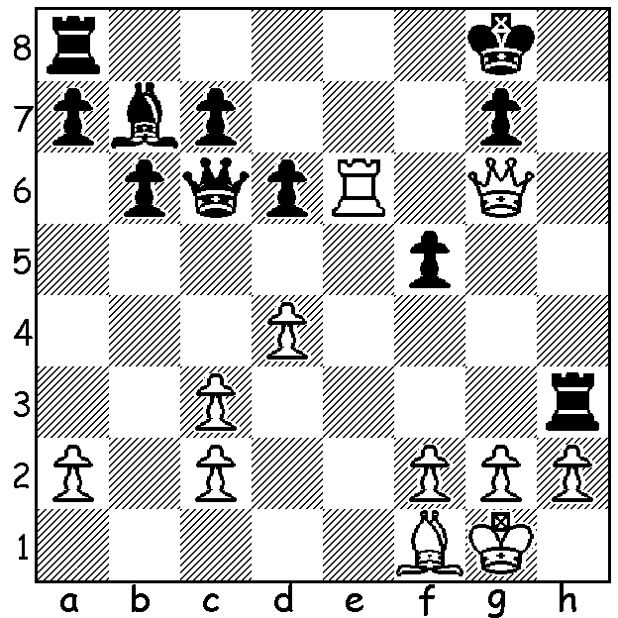
[DIAGRAM HERE]
Keegan O'Mahoney
v David Ellis
White to play and win;
White has the opportunity
of a brilliant mating attack
(8 moves):

WA CHAMPIONSHIPS
The state championship is about half way through and in the Closed event (8 players) the two leaders are the top two rated players, FM Patrick Gong and Ihsan Ferzkohi, both with 3/3. In the Reserves Championship the leaders are Derek Elkington and junior Rebo Fu, both on 3.5/4. They have played each other so each will be keen to achieve maximum points from their remaining games.

SOLUTION: White had made a speculative knight sacrifice, followed by an exchange sacrifice. Black, a rook up was feeling confident, but there is a win for White with 1.Re7. This forces 1...Rh7 which deprives the king of a possible escape square. 2.d5! forces the Black queen off the a8-h1 diagonal to a4 (not 2...Qxd4 3.Re8+ mates) allowing 3.Bd3. Black prevents a rook check with 3...Rf1 and after 4.Bxf5 Qh4 comes the bolt from the blue 5.Qf7+!! Rxf7 6.Re8+ Rf8 7.Be6+ Kh8 8.Rxf8#. Unfortunately for White he missed this but played the immediate 1.d5 allowing 1...Qxc3 guarding the g pawn.. After 2.gxh3 Rf8 3.Re8 the game seemed destined for a draw until a blunder after nearly four hours play cost White his bishop and the game.

