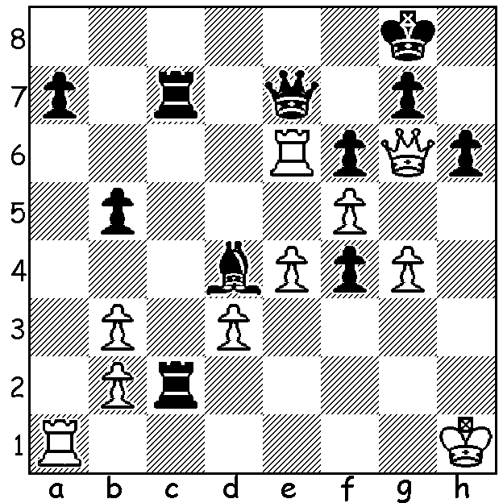

Dominador Andador
vs Kathryn Hardegen:
Another missed brilliancy
from the WA Championship:
Black to play and win
(6 moves):

WA CHAMPIONSHIPS
The state championship is over half way through and in the Closed event (8 players) the two leaders are still the top two rated players, FM Patrick Gong (5/5) and Ihsan Ferozkohi (4/4). Fittingly they will meet in the final round in eight days time. In the Reserves Championship joint leader Derek Elkington was beaten by Saminda De Vos and now shares second place with De Vos, Marcus Simonds and Dylan Gough with 3.5/5 while junior Rebo Fu is now a point ahead with 4.5/5.

SOLUTION: White has sacrificed a bishop to win Black's queen. However Black's combined power of rook, bishop and passed pawn should secure the win with 1...Qf8 2.Re8 f3 and White is helpless, eg 3 Rg1 Rc1! 4.Rxc1 Rxc1+ 5.Kh2 Be5+ 6.Kh3 Rh1#. Black instead played 1...f3? and after 2.Rxe7 Rxe7 the game was ultimately drawn.

