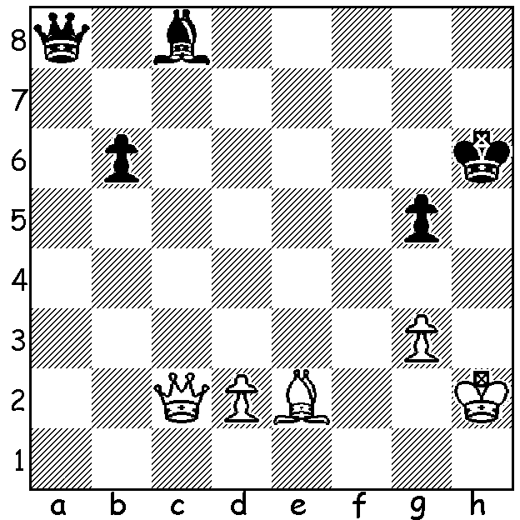

Problem: Villaneuve-Escaplon 1910):
in chess having the move can be
decisive: find wins for both sides:

MAGNUS CARLSEN GRAND TOUR
The finals of the Magnus Carlsen Grand Tour (online) were played earlier this month with best of 5 sets in semi-finals and best of seven sets in the final with each set consisting of 4 rapid games (time limit 15min + 10sec) with two blitz to decide if the score was 2-2 and then an Armageddon game if tied 3-3. In the semis Magnus Carlsen defeated Ding Liren 3-1 while Hikaru Nakamura defeated Daniil Dubov 3-0. Nakamura has a terrible record against Carlsen in Classic chess but he is definitely on a par with the world champion in faster play with the exciting final going to the seventh set. Nakamura led three sets to two but Carlsen won the final two sets to take the $140,000 first prize from total fund of $300,000.



WA CHAMPIONSHIPS
The final round of the WA Championship pits the top two rated players together with Patrick Gong needing only a draw to clinch the title after his coming opponent Ihsan Ferozkholi dropped a half point to a former champion Tim Hare.
In the Reserves Championship junior Rebo Fu with 5.5/6 also needs to avoid loss to take out the Reserves title while his final round opponent Saminda De Vas must win to come equal first.

SOLUTION: White wins with 1.Bh5! Kxh5 (1...Kg7 2.Qg6+ Kh8 3.Qf6+ Kg8 4.Bf7+ or 3...Kh7 Bg6+ both lines mating while 1...Bf5 only delays after 2.Qxf5) 2.Qh7+ Kg4 3.Qh3+ Kf3 4.Qg2+ Kg4 5.Qxa8: Black wins with 1...Bh3! 2.Kxh3 Qh1+ 3.Kg4 Qh5+ 4.Kf5 Qg6+ 5. Ke5 Qxc2.

