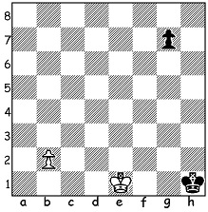

Problem: Isnegger 1964:
White to play and win:

CHESS PROFESSIONALISM
I've been thinking about the rise of professionalism in chess. It seems to have gone hand-in-hand with the development of the electronic media which has enabled chess to become much more of a spectator sport through games being available online. Much of top level chess can be watched live online with commentators or later with computer analysis available. Greater public exposure online results in tournaments funded by online companies, making chess professionalism much more viable. While in earlier times professionalism was limited to the world champions and just a few top grandmasters, today together with roughly 200 players earning a living directly from playing there are thousands involved who combine playing with such things as teaching or coaching, writing books or producing instructional videos. There are also those whose earnings are minimal or non-existent from playing but built entirely around instruction. World champion Magnus Carlsen now earns about $2 million from sponsorships alone yearly while other top GMs can earn from a half a million to a million or more a year. Very different to early days with both Wilhelm Steinitz and Emanuel Lasker, first and second world champions, both dying in poverty. A question: who was the only world champion who was not a professional?

SOLUTION: 1.Ke2! (threatening to win the pawn with 2.Kf3: not 1.Kf2 where White will lose a tempo after ...g3+) 1...Kh2 (1...Kg2 would also lose a tempo by blocking the g pawn) 2.b4 g5 3.b5 g4 4.b6 g3 5.b7 g2 6.b8=Q+ Kh1 (6...Kh3 7.Kf2 wins the pawn, or 6...Kg1 7.Qg3 Kh1 8.Kf2 mating) 7.Qh8+ Kg1 8.Kf3 Kf1 9.Qa1#).

Max Euwe, a mathematics teacher who generally could only compete in tournaments during academic holidays, defeated Alexander Alekhine in 1935 and is acknowledged as the only non-professional world champion.

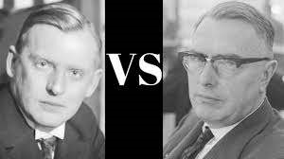
Alexander Alekhine vs Max Euwe

