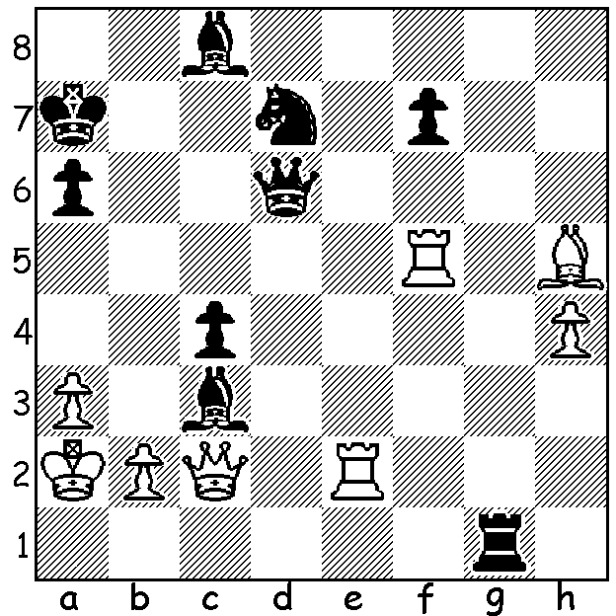

Sagalchik vs Nakamura 2003:
Black wins quickly:

CHESS PROFESSIONALISM
After writing about professional chess players last week and how they earned a living, I came across an article about the American Hikaru Nakamura (top ranked at Blitz and fourth in Rapid) who supplements his earnings from Grandmaster tournaments by taking advantage of the surge in online chess (which he is to a large extent responsible for). Twitch.tv is a live-video streaming website for users to watch others play video games, broadcasting to around 17.5 million viewers a day. In 2015 only about 60 people were watching chess streams at any given time. Today that number is well over 4000. Nakamura began streaming chess on Twitch in 2015 and now has at times over 45,000 viewers watching a single game with Nakamura playing against streamers blindfold or giving up to a queen odds.

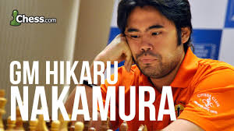

CONGRATULATIONS
The winner of the WA Chess Championship is Patrick Gong while Rebo Fu has won the Reserves Championship. Full report next week.

SOLUTION: 1...Qxa3+!! 2.Kxa3 or bxa3 Ra1#.

