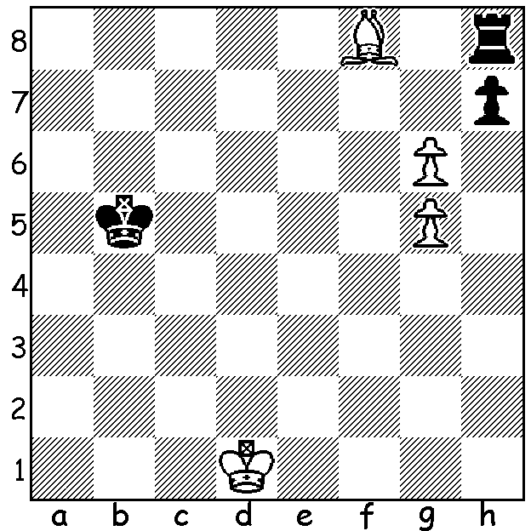

Ivanov 1966:
White to play and win
(move 6 is the ! move):

WA CHESS CHAMPIONSHIPS
The delayed game between the top two players in the WA Championship, Patrick Gong and Ihsan Ferozkohi finished in a draw leaving Patrick on 6.5/7 a half a point ahead of Ihsan who had earlier drawn with 2010 champion Tim Hare. Third and WA Women's champion was Kathryn Hardegen (4/7).

The final round of the Reserves section was also expected to be a tense affair. However Saminda De Vas, needing a win in his game against leader Rebo Fu, inexplicably agreed a draw after one move. Leading scores: Rebo Fu 6/7, Saminda De Vas, Derek Eljington, Oscar Gao 5/7. Oscar secured the Junior prize while Marcus Simonds and Derek Roebuck (4.5/7) shared the Under 1700 Rating prize and Christopher-Jack Andrew and Iker Hernandez Mendez (4/7) shared the Under 1500 award.

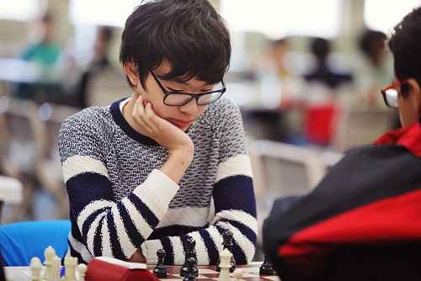
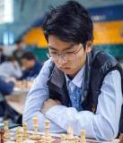
Patrick Gong Rebo Fu

SOLUTION: The first few moves are very obvious: 1.g7 Rg8 2.Ke2 Kc6 3.Kf3 Kd7 4.Kg4 Ke8
5.Kh5 Rxf8 (5...Kf7 6.Kh6 wins) 6.Kh6! (not 6.gxf8=Q+ Kxf8 7.Kh6 Kg8=) 6...Rg8 7.Kxh7 Kf7 8.g6+ winning the rook.

