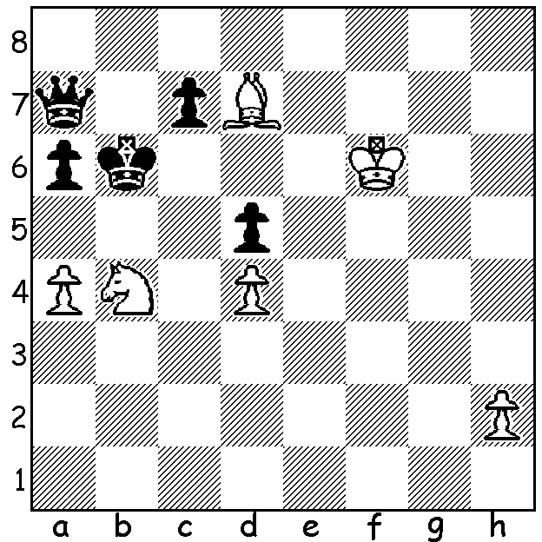

White to play and win:

chess24
The internet chess server chess24.com has been sponsor of many of the online GM tournaments, most of them won by world champion Magnus Carlsen. chess24 was established in 2014 by German GM Jan Gustafsson and Enrique Guzman. It provides live coverage of major tournaments on the website and also on You Tube. Users can also play against each other as well as watching videos on chess subjects. There are also e books and a daily news feature. In March 2019 chess24 was bought by Carlsen's company Play Magnus AS for a reputed $34 million, leaving Carlsen the principal shareholder. Other prominent online chess sites include chess.com and Lichess, both with huge followings.

HOLIDAY CHESS
*WA Junior Allegro, at Leeming Primary on Thursday 1st October, start 10.15.
*WA Junior Rapidplay Championship (25min + 10sec), Monday 5th and Tuesday 6th October at Leeming Primary, starting 10.15am.
*Chess Coaching Clinic for Juniors, Wed 7th and Thursday 8th October, 9.30am - 1pm at Oberther Primary, Bullcreek. The clinic will comprise three groups, Beginner, Intermediate, Advanced. Places are limited so register early for this event and for others at cawa.org.au Players not registered should arrive 30 mins early.

SOLUTION: 1.a5+! Kb7 (1...Kxa5 2.Nc6+) 2.Nc6 Qa8 3.Kg7! Zugzwang! A delightfully unusual coup de grace with a table-turning trapping of the queen by the king. This was a recent chess.com daily puzzle.

