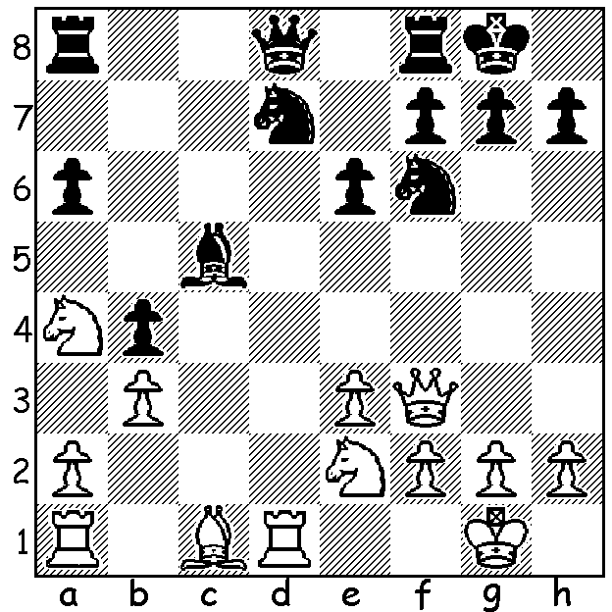

Erwin L'Ami - Alan Pichot
(Banter Chess 2020):
Black takes advantage of
White's two oddly placed
pieces to win material:

BANTER CHESS
The most recent internet chess24 tournament was the Banter KO played throughout September with 132 players (109 GMs). The preliminaries were whittled down to eight players who then faced eight invited players. The time limit was 3min + 2sec with each match consisting of eight games (10 for final). In the semifinals Wesley So defeated qualifier Le Quang Liem from Vietnam, who had eliminated Fabiano Caruana, by 6-3 while world Champion Magnus Carlsen defeated Levon Aronian 5.5-2.5 after walking into a one move mate in game 2 to go 0-2 down. In the final Carlsen won the first two games against So and finished winner 5.5-3.5. One interesting feature was the requirement by players to commentate their own games.

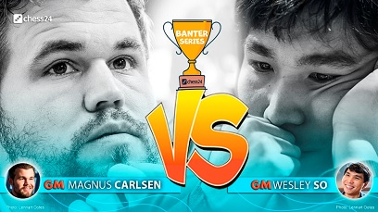

HOLIDAY CHESS
*WA Junior Rapidplay Championship (25min + 10sec), Monday 5th and Tuesday 6th October at Leeming Primary, starting 10.15am.
*Chess Coaching Clinic for Juniors, Wed 7th and Thursday 8th October, 9.30am - 1pm at Oberther Primary, Bullcreek. The clinic will comprise three groups, Beginner, Intermediate, Advanced. Places are limited so register early for this event and for others at cawa.org.au Players not registered should arrive 30 mins early.

SOLUTION: Black wins the exchange (rook for bishop or knight) - 1...Ne5!! 3.Rxd8 Raxd8! (not 3...Nxf3+ gxf3 4.Nxc5). Had the placement of White's queen and knight (e2) been swopped his position would have been sound.

