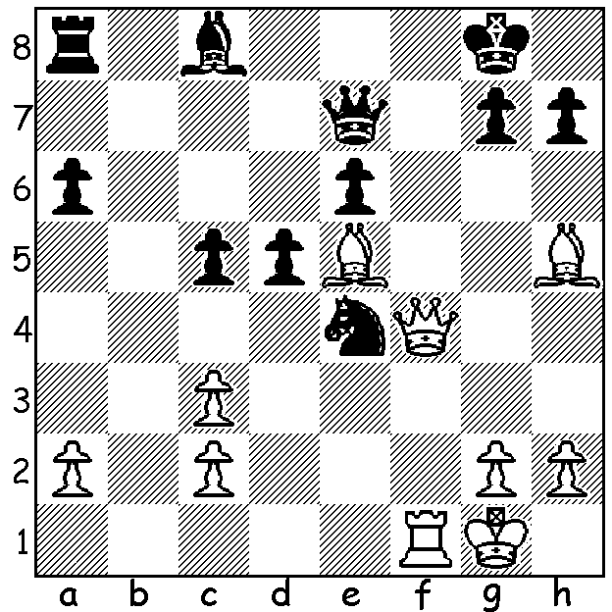

Duda v Oskar Wieczorek 2014
White to play and win
(4 moves)

ALL GOOD THINGS MUST COME TO AN END
Magnus Carlsen's unbeaten run of 125 games in Classic Chess stretching over two years came to an end a week ago when he was beaten by young Pole Jan-Krzysztof Duda in the Altibox tournament in Stavanger, Norway. His victory came on the same day teenager Iga Swiatek won the French Women's Open Tennis Championship. Both were congratulated by the Polish Prime Minister on Twitter. Now aged 22 Duda became a Grandmaster at the age of 15 and reached his peak ranking of 12th last year (now ranked 16th).

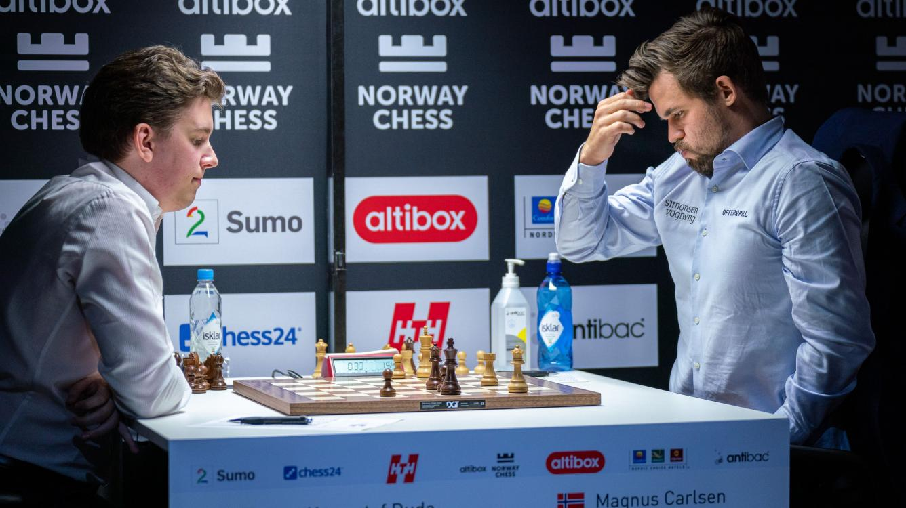

FORTHCOMING WEEKEND EVENTS
The Willetton Open (WA GP) will be played Sat 24 & Sun 25 October at Leeming Primary. Details and entry at cawa.org.au or contact me 0439798607.
The Faber Spring Allegro Championship will take place on Sunday 1 November 10.00 - 3.30 at the Faber Vineyard, Baskerville. Lunch will be available at a very moderate price. I have decided to play and would encourage everyone to enter and make this novel event a real success. Enquiries norbert.muller@iinet.net.au & 0419950619 (see also cawa.org.au).

SOLUTION: 1.Bf7+ Kf8 (the obvious 1...Kh8 loses instantly to 2.Qh6! Nf6 3.Rxf6!) 2.Qg4 g6 3.Bxe6+ Ke8 4.Bxc8.

