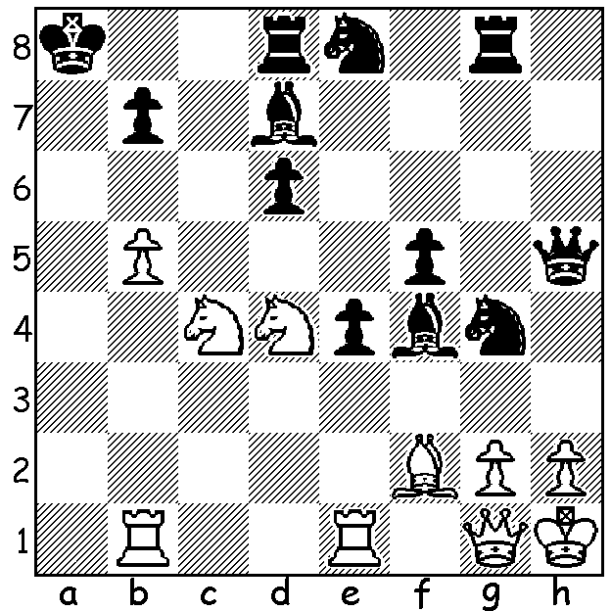

From chess24: White to play and win:
Not only is White a piece down but he
faces a strong attack from four Black pieces.
A dire situation demands desperate measures.
White mates in 8 (not really difficult):

CARLSEN TOP AGAIN
Magnus Carlsen's loss to Jan-Krzysztof Duda in the Altibox tournament, Stavangar, Norway, did not prevent the world champion from winning yet another event, clinching first place in the penultimate round when he defeated his nearest rival, the young star Alireza Firouzja. He then lost his final game to Levon Aronian and finished with 19.5/30. Other scores: Firouzja 18.5, Aronian 17.5, Fabiano Caruana 15.5, Duda 9.5, Aryan Tari, Norwegian champion, 3.5. The event was a double round robin and if the game finished drawn an Armegeddon game (White 10 mins, Black 7 mins with White having to win) would decide. A win in classic chess gained 3 points, 1.5 points for a win in Armegeddon and 1 point for a loss in Armageddon. A pleasing statistic was that only 12 of the 30 classic games (40%) were drawn.

HOLIDAY CHESS
The WA Junior Allegro was won by Jamie Laubbacher who won all his nine games including the double over top rated Rebo Fu. Under 12 winner was Eu Jin Khaw, Under 10 Anthony Nguyen and Under 8 Eric Deng. Celine Ong and Anoushka Gupta shared the Girls' title after winning a game each in a play off. In all 62 children participated.
The two day Chess Coaching Clinic, which concluded with a simultaneous by Grandmaster Temur Kuybokarov, was attended by about 50 students.

FORTHCOMING WEEKEND EVENTS
The Willetton Open (WA GP) will be played Sat 24 & Sun 25 October at Leeming Primary. Details and entry at cawa.org.au or contact me 0439798607.
The Faber Spring Allegro Championship (WA Allegro Grand Prix event) will take place on Sunday 1 November 10.00 - 3.30 at the Faber Vineyard, Baskerville. Enquiries norbert.muller@iinet.net.au & 0419950619 (see also cawa.org.au).

SOLUTION: 1.Ra1+ Kb8 2.Ra8+!! Kxa8 (2...Kc7 3.b6#) 3.Ra1+ Kb8 4.Ra8+ Kxa8 5.Qa1+ Kb8 6.Qa7+! Kxa7 7.Nc6+ Ka8 8.Nb6#. A delightful composition with all the major pieces sacrificed to enable mate with the three minor pieces and the b5 pawn, the key being the double check on move 7.

