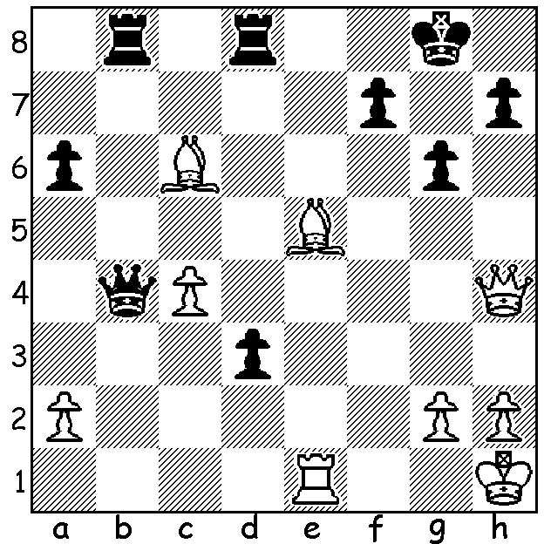

Fabien Libiszewski vs
Temur Kuybokarov 2017
Black to play and win
(7 moves):

AUSTRALIA WINS ASIAN NATIONS
Earlier this month an Australian team, comprising Anton Smirnov, West Australian Temur Kuybokarov, Max Illingworth, Moulthun Ly and James Morris, won the Asian Nations Online Championship defeating chess powerhouse India 4.5-3.5 in the knockout final, winning the first leg 2.5-1.5 and drawing the second 2-2, with Anton and Temur both scoring 1.5/2. Congratulations to all involved.

The Willetton Open (WA GP) was won by Jamie Laubbacher with 5/6, with second place shared between Rebo Fu and Saminda De Vas 4/6. Ian McAteer and Ned Tomic (4/6) shared the Under 1800 Rating prize while Emily Zhang (3) and Yonai De (Vas 2.5) were the Under 1000 winners. Certainly impressive performances by juniors Jamie and Emily who showed maturity well beyond her nine years.

The Faber Spring Allegro Championship (WA Allegro Grand Prix event) will take place tomorrow, Sunday 1 November 10.00 - 3.30 at the Faber Vineyard, Baskerville. Enquiries norbert.muller@iinet.net.au & 0419950619 (see also cawa.org.au).

SOLUTION: 1...Qxe1+! 2.Qxe1 d2 3.Qd1 Rb1! 4.Bf3/a4 (4.Qxb1 d1=Q+) 4...Rxd1+ 5.Bxd1 Re8 6.Bg3 Re1+ 7.Bxe1 dxe=Q# (three sacrifices for promotion and backrow mate).

