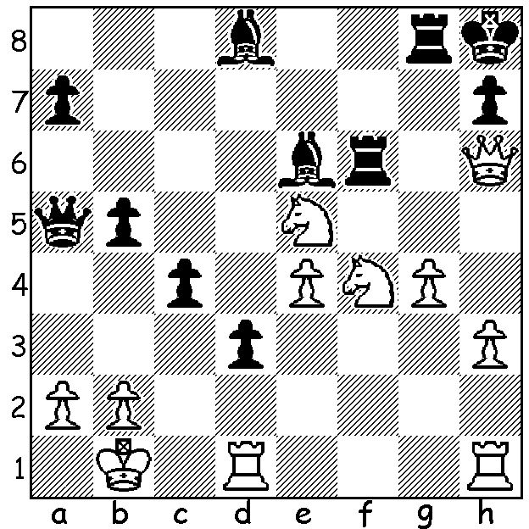

Wesley So v Viktor Laznicka 2011
White to play and win

SO WINS US CHAMPIONSHIP
Wesley So won the US Championship last month with the fine score of 9/11. For So, 27, who had previously won in 2017, this was a welcome return to form. So moved from the Philippines in 2014 and in 2017 was ranked 2nd in the world (now 8th). He is also the world champion in Fischer Random Chess having defeated world champion Magnus Carlsen 13.5-2.5. Second in the US Championship was Jeffrey Xiong (8.5), who earlier in the year was runner-up in the US Junior Championship, with Ray Robson, 26, third (7.5). Clearly Chess is a young person's game! Hikaru Nakamura, top rated in the world at Blitz Chess and US champion 2005, 2009, 2012, 2015 & 2019, had a poor tournament finishing with only 5/11.

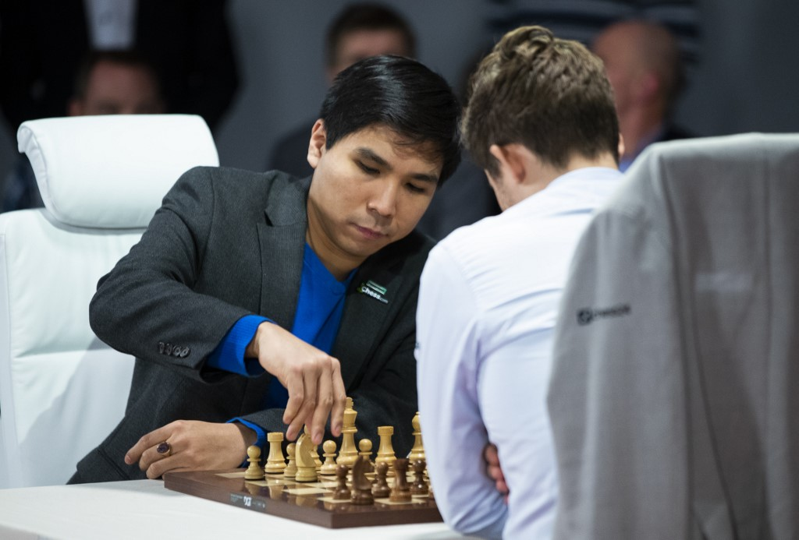
Wesley So at World Random Championship
(note move 1. Nh1-g3.)

KINGSLEY OPEN
The Kingsley Open (WA Grand Prix) will be played on Sunday 15 and Sunday 22 November at N. Woodvale Primary. Note that this marks a departure from the usual Saturday/Sunday format. See cawa.org.au for details or phone 0402 747737.

SOLUTION: 1.Nxe6! if 1...Rxh6 2.Nf7#.

