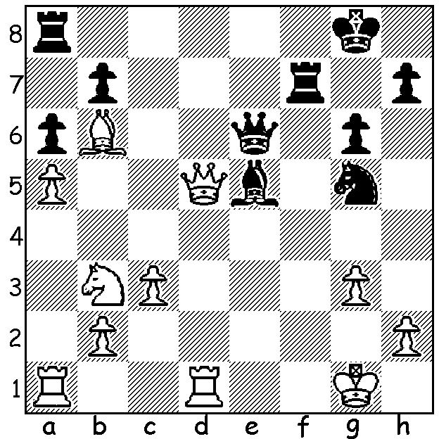

Sergey Dolmatov v Yuri Razuvaev 1993
Black to play and win

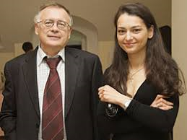
REMEMBERING A TRAINER
The recently completed Razavaev Memorial was
a 5 min + 3 sec tournament played to commemorate
the career of an outstanding Russian trainer Sergey
Razuvaev (1945-2012) with all eight players having
at one time been under his guidance. He was also the
second to Anatoly Karpov in world championship
matches. Winner was ex-world champion Vladimir
Kramnik (6.5/7) who defeated Evgeny Tomashevsky
1.5-0.5 in a play-off (in both games with Kramnik
had assorted material for the queen). Other well
known participants included Ian Nepomniachtchi,
rated world number 4, Boris Gelfand, a former
challenger for the world championship, and Joel Sergey Razavaev with Alexandra
Lautier, a two-time French champion who came Kosteniuk, Womens World champion
out of retirement to play. 2008-2010) whom he trained

KINGSLEY OPEN
The Kingsley Open (WA Grand Prix) will be played tomorrow, Sunday 15th and Sunday 22nd November at N. Woodvale Primary. Note that this marks a departure from the usual Saturday/Sunday format. See cawa.org.au for details or phone 0402 747737.

FROM THE WEST
'Arguing with idiots is like playing chess with a pigeon. No matter how good you are, the bird is going to mess all over the board and strut around like it won anyway.' (anon) - Chrissie Maus, Tuesday Nov 10. Now what was she referring to?

SOLUTION: 1...Bd4+!! 2.Rxd4 (2.Qxd4? Nf3+) 2...Nf3+ 3.Kg2 Nxd4 3.Qxe6 Nxe6 (if 3.Qxd4 Qxb3) and Black won a hard fought ending with rook for bishop and pawn. Dolmatov was World Junior champion in 1993.

