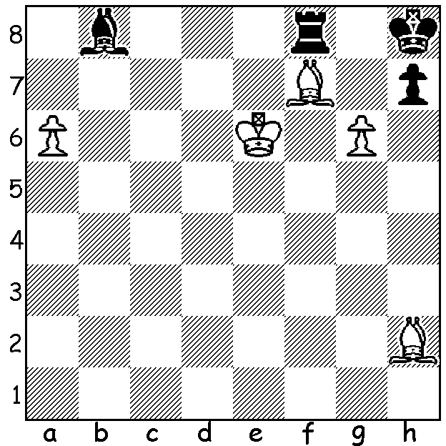

A realistic endgame study by
Pasternak, 1969. Overworked
defensive pieces and a clearance
sacrifice enable White to mate in 5:

50 GREATEST PLAYERS
Grandmasters and Magnus Carlsen trainers Jan Gustafsson and Peter Meine Nielsen created a list of their 50 greatest players of all time for Chess24. 1.Garry Kasparov, 2.Magnus Carlsen, 3.Bobby Fischer, 4.Emanuel Lasker, 5.Alexander Alekhine, 6. Anatoly Karpov, 7. Jose Raul Capablanca, 8. Mikhail Botvinnik, 9.Viswanathan Anand, 10.Paul Morphy, 11. Vladimit Kramnik, 12. Tigran Petrosian, 13.Wilhelm Steinitz, 14.Vassily Smyslov, 15.Mikhail Tal 16.Boris Spassky, 17.Max Euwe, 18.Francois-Andre Philidor, 19.Fabiano Caruana 20.Viktor Korchnoi, etc. Chess24 has produced videos of all fifty.

FABER SPRING ALLEGRO
Twenty players enjoyed chess and lunch at the Faber Winery on November 1 with a strong field which included three former state champions. Winner was junior Rebo Fu (6/7) with Tim Hare & Keegan O'Mahoney close behind on 5.5. Under 1900 prize went to Wolfgang Leonhardt. Organiser Norbert Muller is intending to have four seasonal allegros at various wineries.
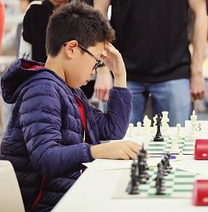

YOUNG WESTERN AUSTRALIAN
PICKED FOR AUSTRALIA
Congratulations to Oscar Gao who has been
selected to represent Australia in the 2020
FIDE Online World Cadets and Youth Rapid
Championships. Qualifying matches are
scheduled 11 - 13 December with finals
19 - 23 December.

SOLUTION: 1.a7! Bxh2 (1...Bxa7 2.Be5#)
2.Be8! Rxe8+ (else 3.a8=Q) 3.Kf7 Rg8
(4.g7# was the threat) 4.a8=Q! Rxa8 5.g7#. Oscar Gao

