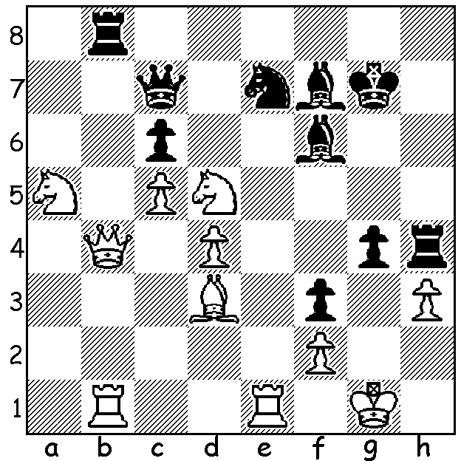
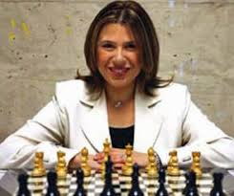
Smirnov v Susan Polgar 1981
Black finds a quick win: Susan Polgar

THE QUEENS GAMBIT (cont)
Firstly a retraction: I was corrected by John Fedec regarding my assertion last week that the novel The Queens Gambit was influenced by the career of Judit Polgar. The book first came out in 1983 while Judit Polgar was born in 1976 and was years from becoming one of the top ten players in the world. There is also a myth that the book is influenced by the career of Bobby Fischer. Instead the character of Beth Harmon is based more on the experiences of the author himself, Walter Tevis. Tevis (1928-1984) was a fascinating character, famous for his short stories and six novels, three of which, The Hustler, The Color of Money and The Man who Fell to Earth, were adapted into major films. He was also an alcoholic, a drug addict, a gambler, a fanatical pool player and a keen, though mediocre, chess player.

RADIO INTERVIEW. If you missed the interview between 6PR's Gareth Parker and WA champion Patrick Gong on Monday, check it out. Also did you see the great eight page Chess lift-out from last Saturday's West?

LAST TOURNAMENTS OF 2020
The last two eventsof the year are:
The Christmas Blitz, 13th December at N Woodvale Primary where end of year trophies will be presented (contact Alan 0439912234):
The Gufeld Cup (WA Grand Prix) Sat 27, Sunday 28 Dec at N Woodvale Primary (contact me on 0439798607).
See cawa.org.au for details of both events.

SOLUTION: 1...Qh2+!! 2.Kxh2 Rxh3+ 3.Kg1 Rbh8 4...Rh1#. Susan Polgar, eldest of the three Polgar sisters was only 12 when she won this game. She was Womens World Champion 1996-9.

