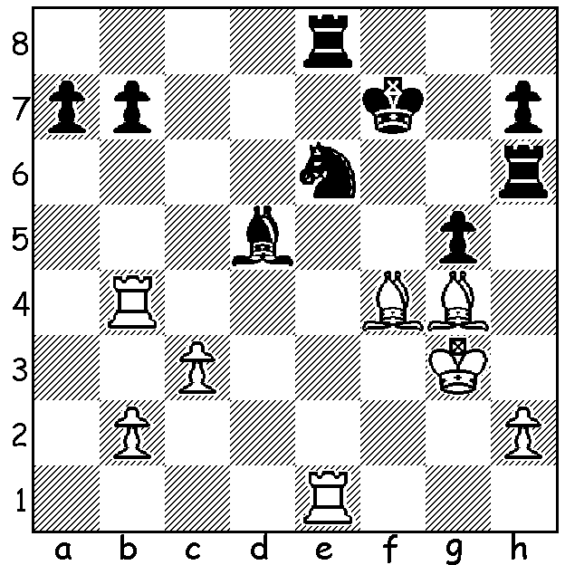
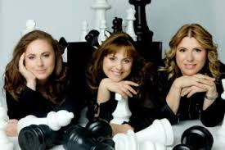
Judit Polgar v Susan Polgar 1993 Judit, Sofia and Susan
White wins material:

TOP FEMALE PLAYERS
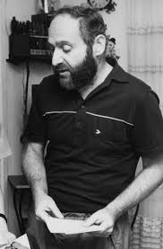
After articles on the serial The Queens Gambit on Netflix, I've
decided to spend a few weeks writing about the careers of
leading female players through the ages. The most famous is
undoubtedly Judit Polgar, although her two sisters, Susan, the
eldest, and Sofia, the second sister, were also outstanding
players. Their father, Laszlo, was a researcher who studied
intelligence, particularly genius. He observed that those classed
as genius had shown outstanding promise at a very early age and
had all been subjected to training at the earliest opportunity. Therefore he presented a theory that great performers in any field
are made not born. He then set out to prove this by marrying and
raising children he would make into geniuses. His wife Klara was
a Ukranian foreign language teacher who was willing to join
Laszlo in his quest. Chess was chosen because it is very objective
and success easy to measure and moreover Susan already enjoyed playing. The three girls, born in 1969, 1974 and 1976, were home schooled with hours spent daily on chess study. Next week Susan
Polgar's career. Laszlo Polgar

LAST TOURNAMENTS OF 2020
The Christmas Blitz, tomorrow, 13th December at N Woodvale Primary where end of year trophies will be presented (contact Alan 0439912234):
The Gufeld Cup (WA Grand Prix) Sat 27, Sunday 28 Dec at N Woodvale Primary (contact me on 0439798607).
See cawa.org.au for details of both events.

SOLUTION: 1.Bxg5! (deflection and clearance sacrifice) if 1...Nxg5 2.Rf4+ with the rook on e8 lost and worse is 1...Rg6 2.Bh5 Nxg5 3.Bxg6+ hxg6 4.Rf4+.

