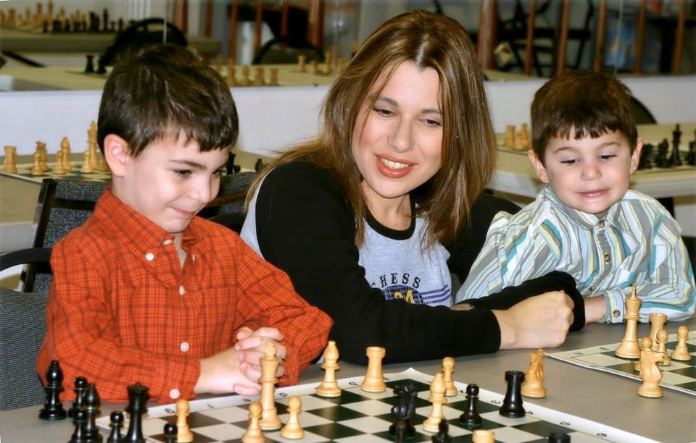
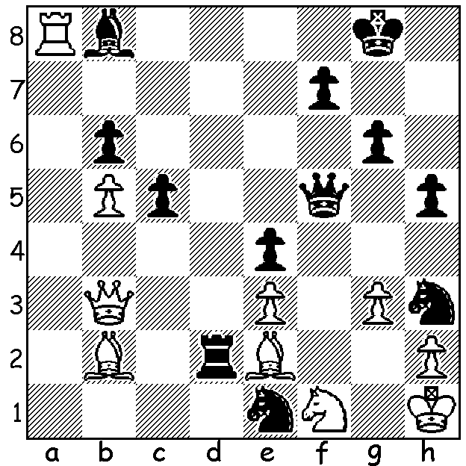
Lajos Portisch v Susan Polgar 1991 Susan Polgar teaching
A spectacular Black mate in 6: the youngsters

TOP FEMALE PLAYERS - SUSAN POLGAR
The eldest of the famous Polgar sisters, Susan, born 1969, who became the top ranked female player in the world at the age of 15, was the third woman to gain the Grandmaster title and held the Womens World Championship title from 1996 to 1999. She emigrated from Hungary to USA in 1994 and is the founder of the Susan Polgar Foundation to promote chess among the young, particularly girls.
Here are some more highlights of her chess career:
● The only woman to win the Triple Crown - Womens World Classic, Rapid and Blitz titles.
● 5 times Olympic Champion with 10 medals and no defeats.
● Most consecutive Olympiad games without defeat, 56.
● Broke four world records for a simultaneous in 2005 including most played (326) and most won (309).
● US Open Blitz Championship winner in 2003, 2005, 2006
.
LAST TOURNAMENT OF 2020
The Gufeld Cup (WA Grand Prix) Sunday 27, Monday 28 Dec at N Woodvale Primary (contact me on 0439798607 or ellisd19@bigpond.com). See cawa.org.au for details. Last chance to gain points for the 2020 GP.

SOLUTION: 1...Qxf1+! 2.Bxf1 Nf2+ 3.Kg1 Nf3+ White resigns (4.Kg2 - now any discovered check mates including the flashy 4...Nh3+ 5.Be2 Rxe2+ 6.Kxh3 or Kh1 Rxh2# or 6.Kf1 Rf2#).

