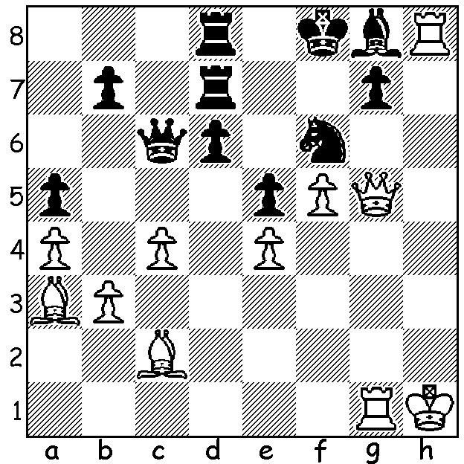


Sofia Polgar vRumiana Gocheva 1990 Sofia Polgar
White wins quickly:

TOP FEMALE PLAYERS - SOFIA POLGAR
The middle Polgar sister, Sofia, born 1974, did not acchieve the success of her more famous sisters, Susan and Judith. She was an International Master and Womens Grandmaster but, unlike her two sisters, did not achieve the Grandmaster title although her top rating of 2505 was not far below that of Susan (2577).
Career Highlights:
■ in 1986 she was second to Joel Lautier in the World Under 14 Championship;
■ in 1989, aged 14, she won a tournament in Rome which included a number of GMs with a sensational score of 8.5/9;
■ in 1994 she finished second in the World Junior Championship in Brazil.
She was married in 1999 to Israeli GM Yona Kosashvili and moved from Hungary to Israel. For a time she was the sixth strongest female player in the world but virtually gave up playing in 2003, instead devoting her time to work as an artist.

LAST TOURNAMENTS OF 2020
The Gufeld Cup (6 round, WA Grand Prix) tomorrow Sunday 27 and Monday 28 Dec at N. Woodvale Primary, start 10.30 (contact me on 0439798607 or ellisd19@bigpond.com). See cawa.org.au for details and arrive by 10.15. Last chance to gain points for the 2020 GP. There will also be a Rapidplay Under 1400 rating event on Monday.

SOLUTION: 1.Qxf6+! (deflection sacrifice) 1...gxf6 2.Rhxg8+ Kf7/e7 3.R1g7#.

