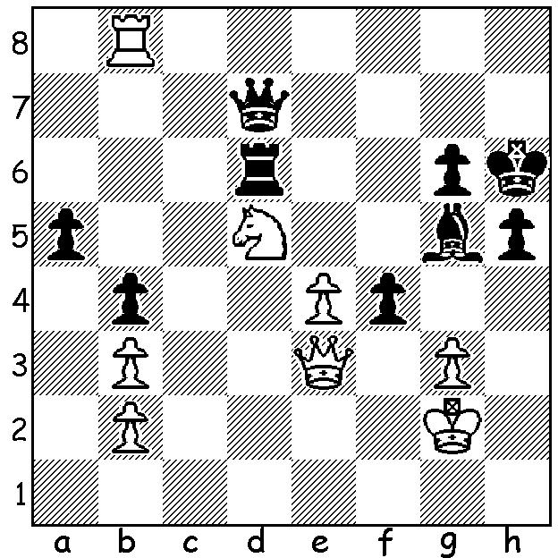
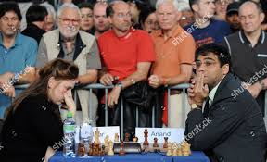
Judith Polgar v Vishy Anand 1998 Judit Polgar & Vishy Anand
White finishes a piece up after 6 moves:

TOP FEMALE PLAYERS - JUDITH POLGAR

The youngest of the famous Polgar sister, Judith, born 1976, became a Grandmaster at the age of 15, at the time the youngest to have done so, breaking the record of Bobby Fisher. She was the youngest to break into the FIDE top 100 players
list, ranked No 55 in 1989 when only 12. She is
the only woman to achieve the 'super' GM rating
of 2700+ and reached a career high FIDE
position of 8th. She was also the No 1 rated
female from 1989 to her retirement in 2014.
However, apart from representing the
Hungarian women's Olympiad team in 1988
and 1990 and, at the age of 10, playing in the
Girls Under 16 World championship, she
always spurned women-only events. She is
the only woman to have won a game against
a reigning World No 1 (Garry Kasparov) and Garry Kasparov and Judith Polgar
has beaten eleven then current or previous world champions in either rapid or classical chess. She was married in 2000 to Swede Gusztav Font and has two children, Hanna and Oliver.

CHESS on the FRINGE
Chess becomes part of this year's Perth Fringe Festival with three Blitz competitions (Jan 15, 16 and 22) and a 20 Board Grandmaster Simultaneous exhibition by the Australian champion, WA's Temur Kuybokarov, on Saturday 23. Check cawa.org.au for details and get in early to play Temur. And, by the way, did you see Temur's interview on Channel 10 earlier this week? If not check it out.

SOLUTION: 1.Rh8+ Kg7 2.Qd4+!! Bf6 3.Qxf6+! Rxf6 4.Rh7+! Kxh7 5.Nxf6+ Kg7 6.Nxd7.

