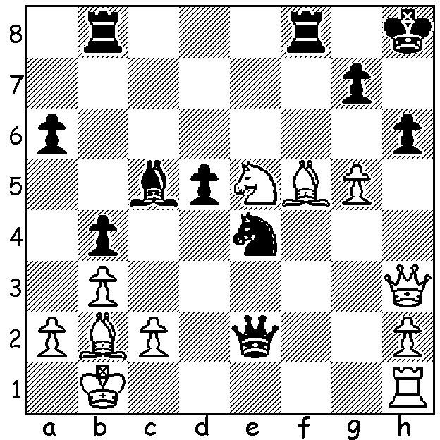
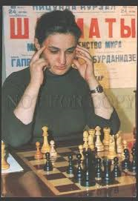
Maia Chiburdanidze v Bent Larsen 1993
White mates quickly against
one of the world's best:

TOP FEMALE PLAYERS - MAIA CHIBURDANIDZE
Born in January 1961, Georgian GM Maia Chiburdanidze was the third longest holder of the Womens World Championship title (1978-1991).
Main achievements:
* USSR Girls Champion at 15;
* USSR Womens Champion at 16;
* became Womens World Champion by defeating Nona Gaprindashvili 8.5-6.5;
* defended the title successfully four times before losing to Hou Yifan 6.5-8.5.
* member of dominant USSR Womens Olympiad teams in the 1980s;
* when Georgia obtained independence played Bd 1 for her country which won 4 gold medals 1992-2008;
* highest rating 2661, ranked 42 in world.
Despite her successes in women's chess she preferred to play in open competitions and gained a number of top places.

CHESS on the FRINGE
I shall be at the Grand Blitz this afternoon, 2-4pm (only watching), in the State Theatre Centre Courtyard and am hoping to see many of Perth's Chess community there. Next week it's Australian champion Temur Kuybokarov against all comers. Check cawa.org.au for details of how to register to play Temur.

SOLUTION: 1.Qxh6+! gxh6 2.Nf7+ Kg8 3.Nh6#.
Last week's solution contained an inaccuracy -
Hou Yifan v Georgescu: 5R1K/7P/P2P1P2/1P1bRrBp/3Qp3/3p2q1/p5pq/5r2: correct solution 1.Qxg5! fxg5 2.Rxf8+ Kg7 3.Rf6! (threat 4.h6+ and if 3...h6 4.R6f7#). Thanks Tristan Boyd for being first to point this out.

