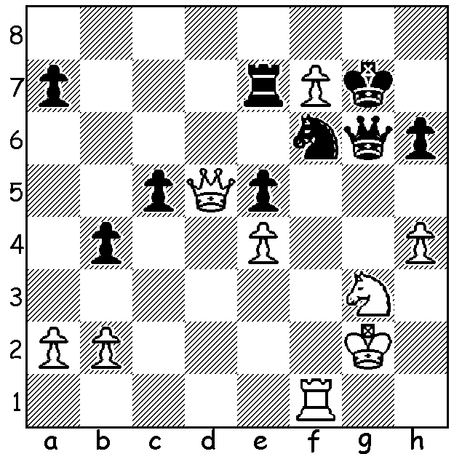
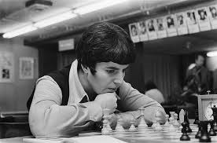
Nona Gaprindashvili v Milutin Kostic 1995
White wins quickly:

TOP FEMALE PLAYERS - NONA GAPRINDASHVILI
Born in May 1941, Georgian Nona Gaprindashvili won the Womens World Championship title in 1961 by the score of 9-2 and defended the title successfully four times before losing to Maia Chiburdanidze 6.5-8.5 in 1978.
Main achievements:
* First woman to gain the Grandmaster title;
* USSR Womens Champion five times;
* played in 11 Olympiads for USSR (& once for Georgia) gaining 25 medals; in the Dubai Olympiad she score 10/10.
* highest rating 2495.
I saw her play at Hastings in 1963/4 (I had gone to play and watch Mikhail Tal) where she won the Challengers. The following year she played in the Premier scoring 5/9.
Her greatest open success was in Lone Pine, USA, when she headed a field of 45 of which most were GMs.

CHESS on the FRINGE and other events
I shall be at the 20 Board Grand Grandmaster Simultaneous Exhibition this afternoon, 2 - 4 pm in the State Theatre Centre Courtyard where Australian champion GM Temur Kuybokarov takes on twenty challengers at once (spectators welcome).
Sunday 31 January, 1 - 4 pm, State Library Blitz.
Sunday 7 February, 10 am to 3.30 pm, Conti Summer Allegro at Conti Wines, Woodvale.
Details of events cawa.org.au (calendar).

SOLUTION: 1.Rxf6! if 1...Kxf6 2.f8=Q+ & if 1...Qxf6 2.Nh5+ / 3.Nxf6

