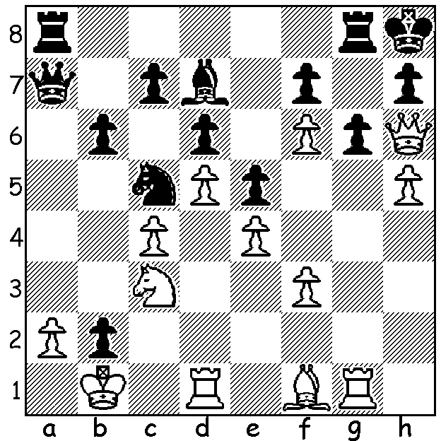
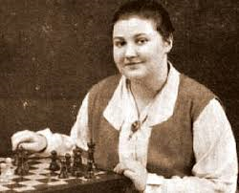

Vera Menchik v Sir George Thomas, 1932
White has a sensational finish against a two-times British champion.

TOP FEMALE PLAYERS - VERA MENCHIK
I now come to the end of articles featuring women who have made their mark on open chess. The very first Womens Champion, Vera Menchik, was born in Moscow of a Bohemian father and English mother in 1906. Losing his mill and house after the Russian Revolution, her father returned to Bohemia while Vera, her mother and sister settled in Hastings, famous for its annual chess congress. Vera, who had learnt chess as a nine year old, became a pupil of the famous GM Geza Maroczy in 1923 and was acknowleged as the best female player in UK by 1925. She won the Womens World Championship in 1927 and successfully defended her title six times in tournaments, losing only one game, drawing 4 and winning 78 while also winning two matches against Sonja Graf (+3, -1, =0 & +9, -2, =5). She played regularly in open events but with little success although she did secure wins against such players as Alexander, Euwe, Saemisch, Reshevsky and Yates, all prominent GMs. Sadly Vera, who had endured the loss of her mother and sister, killed during a V1 rocket attack during WWI, similarly lost her life during a bombing raid in 1944.

CHESS on the FRINGE and other events
The four chess events at the State Theatre Centre Courtyard over two weeks were a great success and concluded with Australian champion GM Temur Kuybokarov taking on twenty challengers at once, watched by a crowd of between 50 and 100.
Tomorrow, Sunday 31 January, 1 - 4 pm, State Library Blitz.
Sunday 7 February, 10 am to 3.30 pm, Conti Summer Allegro at Conti Wines, Woodvale.
Details of events cawa.org.au (calendar).

SOLUTION: 1.hxg6 fxg6 2.Qxh7!!+ Kxh7 3.Rh1+ Bh3 4.Rxh3#.

