
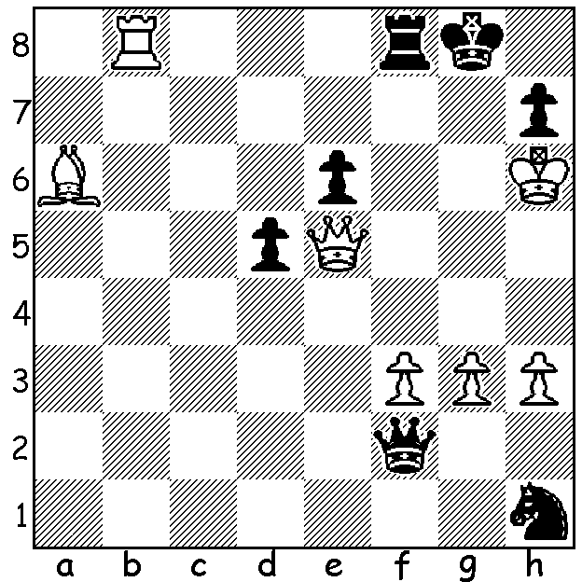

Giri Van Foreest
Jorden Van Foreest v Nils Grandelius
Final Round Tata Steel 2021: Black resigns. Can you see Black's move
to stop the obvious mates and then find the spectacular White mate in 2?

YOUTH TO THE FORE AT TATA STEEL 2021
The annual Tata Steel tournament, Wijk aan Zee, which has been held virtually uninterrupted since 1938, finished in a two-way tie for first place between two Dutch players, Anish Giri, who had been in sole lead for a number of the latter rounds, and Jorden Van Foreest (8.5/13). A play-off resulted in a win for Van Foreest in an Armageddon game after two Blitz draws, leaving Giri a second time playoff loser, having been beaten by Magnus Carlsen in 2018. Other leading scores: Andre Espenko, Alireza Firouzja, Fabiano Caruna, the 2020 winner, 8. The tournament was a triumph for youth with Van Foreest 21, Espenko 18 and Firouzja 17. World Champion Magnus Carlsen, who had won the event seven times since 2010, finished on 7.5, his sole loss being against the young Russian Espenko. 2021 was the first time a Dutch player has won the event since Jan Timman in 1985.

WA CHESS POSTPONEMENT
The Conti Summer Allegro at Conti Wines planned for Sunday 7 February has been postponed due to the uncertainty of when covid restrictions will be lifted. Other events planned by CAWA and clubs may also have to be postponed.

SOLUTION: 1...Qa7 prevents 2.Qg7# and defends against 2.Qxe6+ Qf7 but allows 2.Qh8+!! Kxh8 3.Rxf8#. This finish with the White king advancing towards h6 to assist in mating might remind readers of the famous 1991 Nigel Short vs Jan Timman game described as 'The Greatest King March Ever.'

