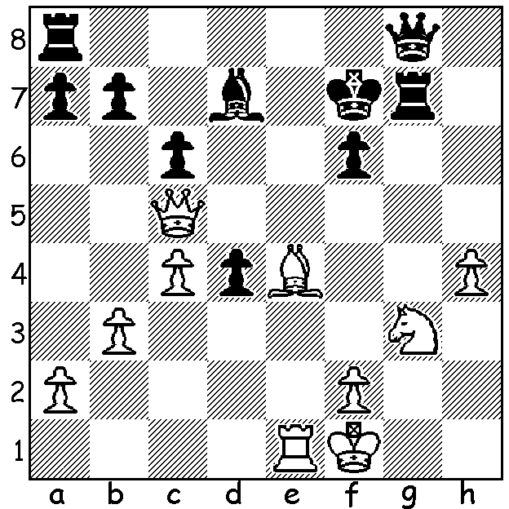
Magnus Carlsen v Helgi Gretarsson 2003:
White mates quickly:

WHEN WILL MAGNUS RETIRE?

In an interview before the recent Tata Steel event, in
which he only managed 6th out of 14, world champion
Magnus Carlsen spoke about his career and future,
stating he intended retiring at 40, which is in 10 years time. He also said that he had been feeling a lack of
motivation. And perhaps that is no wonder considering
his heavy schedule with chessgames.com listing3,617
Classic games played between 1999 and now, about 22
years. Compare this with Garry Kasparov with 2,403
games from 1973 to basically 2005 (32 years) when he
announced his retirement, and also with another world Carlsen at interview
champion Jose Raul Capablanca with 1,822 from 1893
to 1941, 48 years. The percentage scores are also revealing - Carlsen 62.6%, Kasparov 69.8%, Capablanca 73.8% - surely showing the present world champion has many more players closer to his own standard. Then there are also the numerous Rapidplay and Blitz competitions Carlsen takes part in. It will be interesting to see if he can come out on top in his title defence later this year.

PERTH OPEN
The Perth Open will be played Saturday 20th and Sunday 21st of February at N. Woodvale Primary starting both days at 10.30. Check details caea.org.au or contact Andrew 0407421084. The event is part of the WA Grand Prix which this year incorporates not only 60min events but also Rapidplay and Blitz.

SOLUTION: 1.Bg6+! 1...Rxg6 (clearance & obstruction sacrifice)2.Qe7# or 1...Kxg6 2.Qh5# (clearance & deflection sacrifice).

