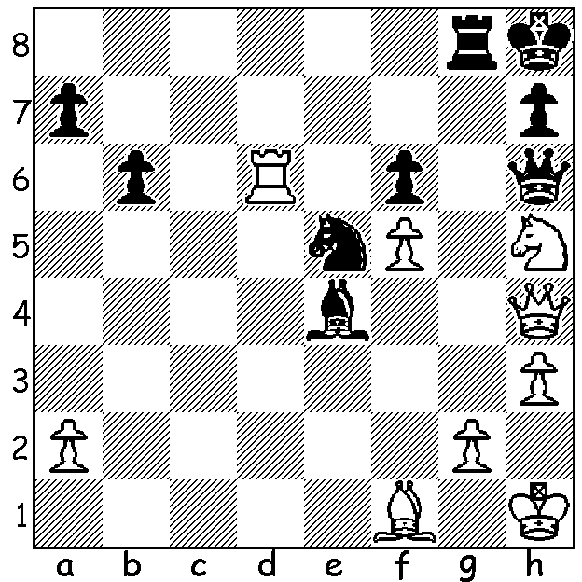
Maxim Rodshtein v Wesley So 2010
With both sides attacking Black, to move, gets in first:

SO DEFEATS CARLSEN
Earlier this week Wesley So defeated world champion Magnus Carlsen in the final of the on-line Opera Euro Rapid championship. After a 2-2 draw in the first set of games So won the first and drew the remaining three games of the second set. Play-off for third saw Teimour Radjabov overcome Maxime Vachier-Lagrave.
The event started with a 16 player all-play-all before the KO stage with eight players, including Levon Aronian, Anish Giri, Daniil Dubov and Jan-Krzyszt Duda, going into a two set (each of four games) mini-match with tie breaks available to resolve 1-1 results. A notable failure to advance to the KO was Hikaru Nakamura who lost his final game to compatriot Sam Shankland.
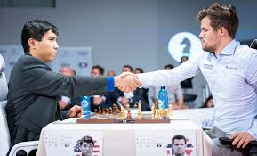

PERTH OPEN & CONTI SUMMER ALLEGRO
If you see this early enough, get along to the Perth Open today and tomorrow at N. Woodvale Primary starting both days at 10.30. Check details cawa.org.au or contact Andrew 0407421084.
The Conti Summer Allegro will take place next weekend, Sunday 28 February starting at 10 am. Contact Norbert Muller to enter or for further information 0419950519.

SOLUTION: Two deflection sacrifices ensure the win: 1...Bxg2+! 2.Bxg2 Qc1+ 3.Kh2 Nf3+! 4.Bxf3 Qg1#.

