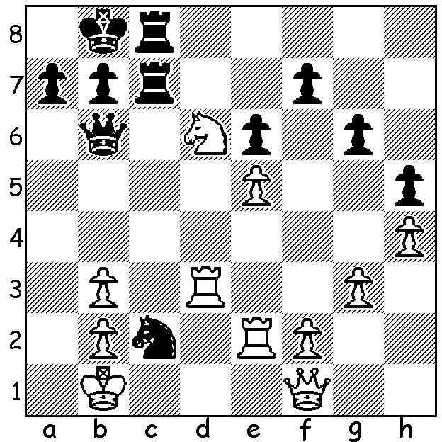
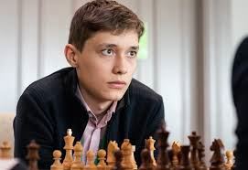
.
Alexander Morozevich Andrey Esipenko
v Andrey Esipenko 2018:
Black to move and win
(2 variations):

A NEW STAR
Just as in any other sport the passage of time sees youngsters emerging and reaching the top while older players lose their preeminence or retire. World Champion Magnus Carlsen put it on record that he would retire around the age of forty. Who then will take the place of such players as Carlsen, Fabiano Caruana, Wesley So and Anish Giri? I intend over the next few weeks to suggest young players likely to reach the very top in Chess. One player is Russian Andrey Esipenko, born 2002, who recently defeated Carlsen in the Tata Steel in their first meeting with the defeat being Carlsen's first loss in Classic Chess to a teenager since 2011. Here are some of Esipenko's achievements:
* European U10 Champion 2012;
* FIDE Master 2013;
* Awarded Grandmaster title 2018;
* European & World U16 Champion 2017;
* =1st in Gibralter Masters (losing playoff) 2020;
* 3rd in Tata Steel (8/13) behind Jorden Van Foreest & Anish Giri (8.5) but ahead of Carlsen.

The CONTI SUMMER ALLEGRO will take place, tomorrow Sunday 28 February, starting at 10 am. However, because of heavy booking at the winery after the recent covid restrictions, it will be held at NORTH WOODVALE PRIMARY. If sufficient entries, a separate U1400 tournament will be played. Contact Norbert Muller to enter or for further information, 0419950519.
And pencil in Sunday 7 March for the WA Allegro (Rapidplay) Championship.

SOLUTION: 1...Nb4! and if 2.Nxc8 Qa5! 3.Rc3 Qa2+ 4.Kc1 Qa1+ wins Queen. The defensive 2.Nc4 loses to 2...Qa6 3.Qd1 Rxc4! 4.bxc4 Qa2+ 5.Kc1 Rxc4+ 6.Kd2 (6.Rc3 Qa1+ 7.Kd2 Rd5+) 6...Qxb2+ 7.Ke3 (7.Ke1 Nxd3+ 8.Qxd3 Rc1+) 7...Qxd4+ 8.Kf3 Qf5+ 9.Ke3 Qe4+.

