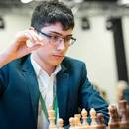
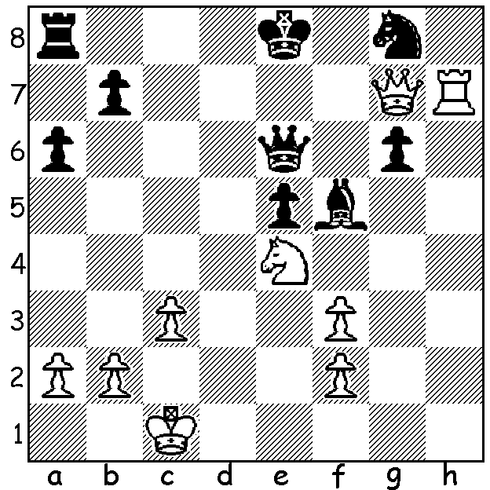
.

Alireza Firouzja vs
Giga Kuparadze 2018:
White mates in 4:

RISING STARS, Part 2
I asked last week, "Who .. will take the place of such players as Carlsen, Fabiano Caruana, Wesley So and Anish Giri?" One is a player mentioned a number of times already in this column, seventeen year old Iranian born Alireza Firouzja, born June 2003, who at present is ranked 13th in the world. In 2019 he announced he would no longer play under the Iranian flag after Iran withdrew its players from the 2019 World Rapid and Blitz Championships to avoid playing with Israelis. He is currently based in France and intends to play under the French flag. Here are some of Firouzja's achievements:
* 2016 won the Iranian Championship (+5 = 6 -0) aged 12 and became an International Master:
* 2018 awarded Grandmaster title, scored 8/11 in Olympiad (Bd 4), won European Fischer Random Championship (+7 =2 -0), won French Rapid Championship, runner-up in World Rapid (+8 =5 -2);
* 2019 Iranian champion (+6 +2 -1)
* 2020 defeated world champion Magnus Carlsen 8.5-7.5 in final of on-line Banter Blitz Cup, runner-up to Carlsen in Norway Chess Supertournament ahead of Fabiano Caruana and Levon Aronian, among others;
* 2021 3rd in Tata Steel Tournament (ahead of Carlsen).

The WA ALLEGRO CHAMPIONSHIP will take place, tomorrow Sunday 7th March, at Leeming Primary, starting at 11 am. See cawa.org.au for details and entry or contact Andrew at 0407421084.
The SCHOOLS CHESS LEAGUE (Nothern Zonal, Primary & Secondary) will also be held tomorrow. Venue N Woodvale Primary starting at about noon. Contact Alan at alnjen@upnaway.com or 0439912234.

The SUMMER ALLEGRO, played last week at the Perth Club, was won by Jamie Laubbacher with 6.5/7 with Rebo Fu (5.5) second and Niels Hansen (5) third. 1st Under 1850 Edward Curthoys and 1st Under 1500 David King.

SOLUTION: 1.Nd6+! Qxd6 (1...Kd8 2.Qf8+ Qe8 3.Qxe8#) 2.Qf7+ Kd8 3.Qxg8+ Qf8 4.Qxf8#.

