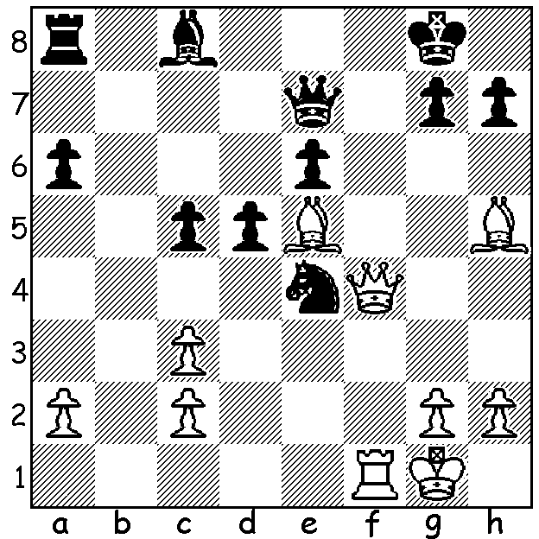
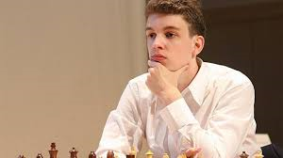
Jan-Krzysztof Duda vs Oskar Wieczorek 2014 Jan-Krysztof Duda
White to play and win:

RISING STARS, Part 3
I asked a fortnight ago week, "Who .. will take the place of such players as Carlsen, Fabiano Caruana, Wesley So and Anish Giri?" Another leading younger player is 22 year old Polish GM Jan-Krzysztof Duda (born 1988), ranked 12th in the world in 2019.
Some highlights of his career:
* 2008 won the Under 10 World Youth Championship;
* 2012 Under 18 Polish champion, gained his IM (international Master) title;
* 2013 became GM (Grandmaster) at 15 years and 21 days;
* 2015 1st= in World Junior Championship (silver medal after tiebreaks);
* 2018 Polish champion, became No 1 ranked junior in the world, runner-up in World Blitz Championship (behind Magnus Carlsen);
* 2020 brought an end to Carlsen's 125 game unbeaten streak in classic chess.

The WA ALLEGRO CHAMPIONSHIP (29 entrants) held last Sunday 7th March was won by Jamoe Laubbacher with 8/9 with his only loss being in the final round to Tim Hare. This enabled Tim (6) to win the Senior prize. Second was IM Patrick Gong (7.5) with Ihsan Frezkholi (6.5) third. Rating prizes were won by Edward Calado (Under 2100), Daniel Clarke (Under 1900) & Richard Shaw (Under 1500).

SOLUTION: 1.Bf7+ Kh8 2.Qh6 Nf6 (2...Qf8 3.Bg6 Qg8 4.Qxg7+! Qxg7 5.Rf8#) 3.Rxf6! gxh6 4.Rg6+/Rxh6/Rxe6+; if 1...Kf8 2.Qg4 Nf6 (2...g6 3.Bxg6+) 3.Bxf6 gxf6 4.Qg8#.

