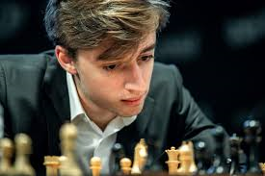
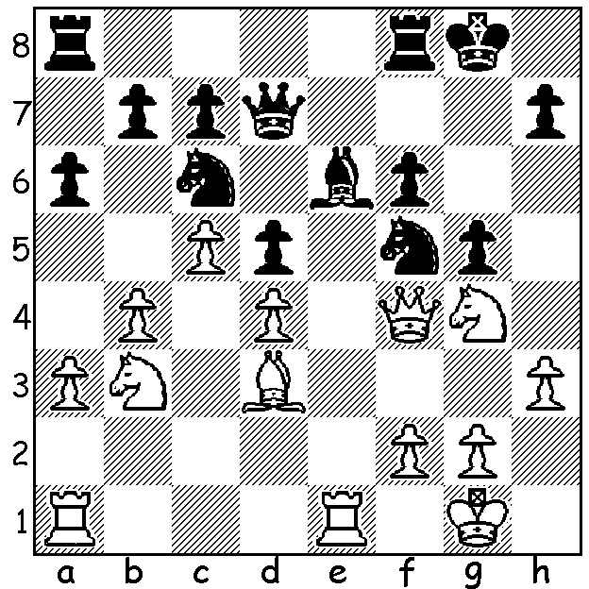
.
Daniil Dubov v Sergey Melnikov 2004 Daniil Dubov
White to play and win (4 moves):

RISING STARS, Part 4
In seeking to answer the question who will take the place of such players as Magnus Carlsen, Fabiano Caruana, Wesley So and Anish Giri, I come to 24 year-old Russian Daniil Dubov (born 1996) who became a Grandmaster aged 14 years and 11 months in 2011.
Some highlights of his career:
* 2015 1st= Aeroflot Open (placed second to Ian Nepomniachtchi on tiebreak);
* 2016 won bronze medal at World Blitz Championship;
* 2018 served a one of Magnus Carlsen's seconds in Carlsen's World Championship match;
* 2018 won World Rapid Championship;
* 2020 defeated Carlsen 2.5-0.5 in quarter finals of Airthings Masters (online rapidplay).

TEMUR AT BALLARAT
Australian Champion GM Temur Kutbokarov recently travelled from Perth to play in the prestigious Begonia Open in Ballarat, Victoria. The record entry of 157 players contained 5 Grandmasters and 4 International Masters. Temur scored 6/7 to share first place with four others including veteran Darryl Johansen who notched up his 14th first place there.

The GUFELD CUP (WA Grand Prix) will be played over Easter, Sunday 4 & Monday 5 April.
More details next week.

SOLUTION: 1.Bxf5!! Bxf5 (1...gxf4 2.Bxe6+ wins piece) 2.Qxf5! Qxf5 3.Nh6+ / 4.Nxf5 (White could also win with the less spectacular 2.Nh6+ / 3.Qxf5)

